

Tuesday 15th September

LI: To retell a story

Steps to Success:

* I talk about the story.
* I retell the main events of the story in order.
* I use key words from the story.

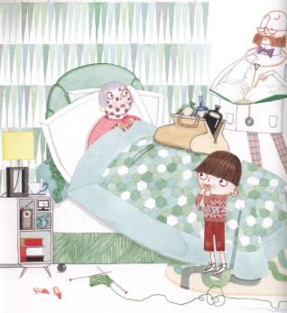Draw a map of Jack’s adventure from Granny to the Isle of Blowyernose.  
Label the map with key words. You can use a word bank to help you.