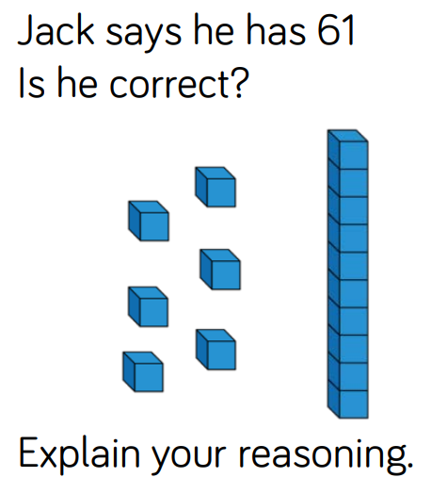  1. | 1.
1. | 1.
1. | 1.

2. 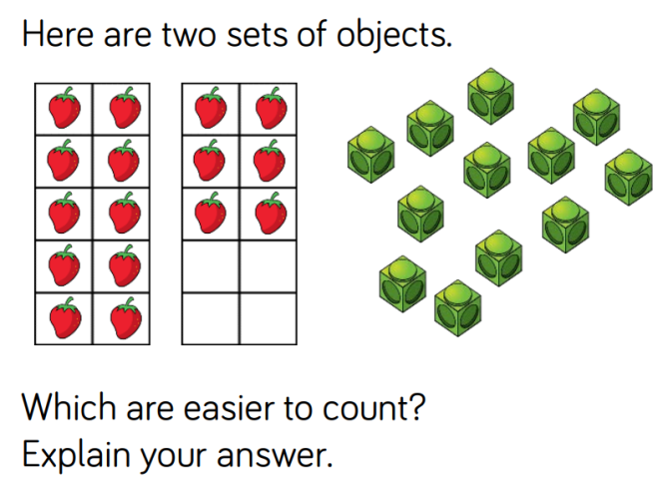  strawberries cubes | I think the ____________________ are
 | easier to count because

2.  strawberries cubes | I think the ____________________ are
 | easier to count because

2.  strawberries cubes | I think the ____________________ are
 | easier to count because

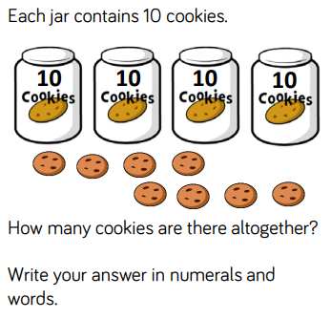  3. | 3.
3. | 3.
3. | 3.

