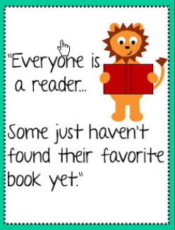
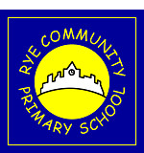
Rye Community Primary School
Reading Newsletter Issue 3
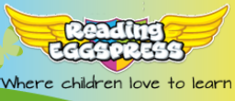
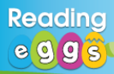
Spring Term 1 2021
Reading Eggs is here!
Reading Eggs arrived with a bang last term and
it was lovely to hear so many children talking
about it on the playground, positive comments from parents and just a general enthusiasm towards the programme.
Things are going to be different again now that we are all learning at home for the next term. Reading is as important as ever and we urge everyone to be reading on a daily basis. Reading is the answer to everything and the more we read, the more we’ll understand. Please endeavour to read everyday and don’t forget to let your teachers know how much you’re reading at home. We love hearing about your home learning.
Welcome back to the third addition of our reading newsletter dedicated only to books! You can find out what we are doing to promote reading across the school, along with book recommendations from book-loving teachers and children.

If you would like some additional information on how to get the most out of Reading Eggs, please visit the following website where there are some short but informative videos.
Distance Teaching Resources - 3P Learning Help Hub
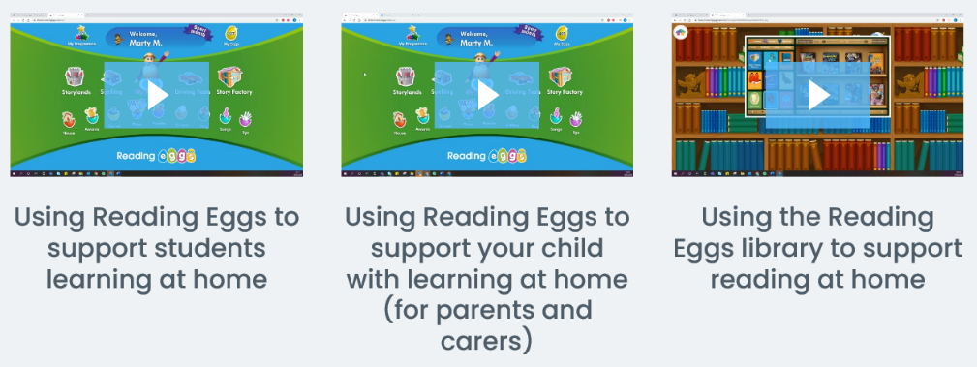
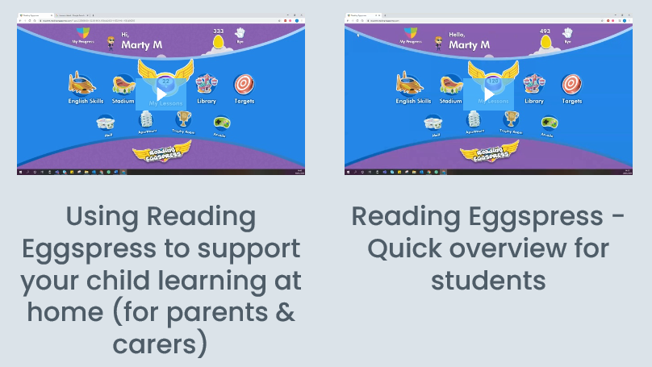

Don’t forget to visit the ‘Library’ on Reading Eggs and Reading Eggspress. It’s amazing and has over 2500 books to choose from.

What books are we studying in Spring Term 1?
Each year group has set text(s) for reading and writing that develop core objectives and key skills. This is what each year group will be studying during Spring 1.
 | Focused Reading Text(s) |  | Writing Stimulus
Pugwash | 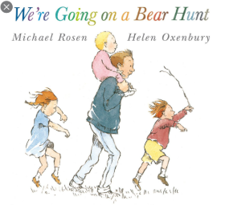  “We’re Going on a Bear Hunt” by Michael Rosen
EYFS | 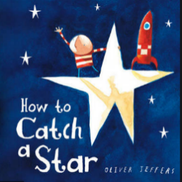  “How to Catch a Star” by Oliver Jeffers
Year 1/2 | 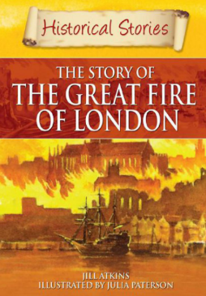  Historical Stories: The story of the great Fire of London |  |  | 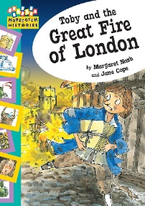  “Toby and the Great Fire of London” by Margaret Nash
Year 3/4 | 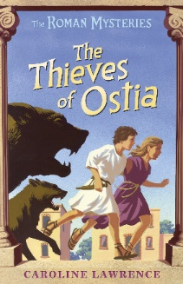  “The Thieves of Ostia” by Caroline Lawrence
Year 5/6 | 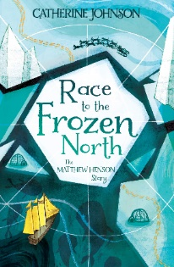  “Race to the Frozen North” by Catherine Johnson. |  | 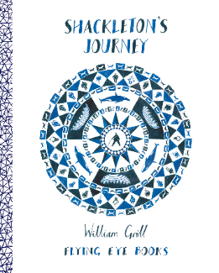  “Shackleton’s Journey” by William Grill
Please Read at Home!

Brilliant Book Talk wherever you are.

Every teacher and parent knows that reading matters. It matters to our childrens’ language development along with their academic success, whilst mattering because of its tremendous power to offer us pleasure and comfort in what are immensely challenging times.

The reading focus will be different for children in different age groups. Broadly, it may match the following pattern:
•In early primary, activities that target reading with an attention to letter sounds and word reading;
•In later primary, activities that support reading comprehension through shared book reading.

The Education Endowment Foundation guidance report Preparing for Literacy provides parents with a simple recipe for reading together, especially during this time when we might have to continue learning from home.

Here are some great sentence starters to get conversations between you and your child going.

- Take turns to make plans and predictions before reading: ‘I wonder if… what do you think?’ ‘You think… Oh, I thought…’

- Recap to check ideas and understanding as your child is reading: ‘So, you think that…’ ‘Did you expect…to happen?’ ‘Why do you think that happened?’

- Use encouragement and praise to keep children engaged in reading: ‘What brilliant ideas…let’s see what happens.’ ‘You thought so carefully about... What might happen now?’

- Share prior knowledge and past experiences that link to what is being read: ‘Have you learnt about…at school?’ ‘Do you remember when we watched…and found out about…’

- Tune-in and listen to your child – be curious about their interests: ‘I didn’t know you knew so much about…’ ‘I love reading stories about...with you.’

Of course, we should aim to convey a love of reading too!

Reading instructions, recipes, and even old baby books, are all valuable. Children should be encouraged to return to their favourite stories, given the likely emotional benefits during this tricky time. Indeed, in such uncertain times, children may gain comfort from reading a book they enjoyed as a very young child or sharing an article from Newsround or another favourite website. Anything that creates a healthy discussion, will encourage a love of reading.
Miss Brassleay Recommends for Spring 1…
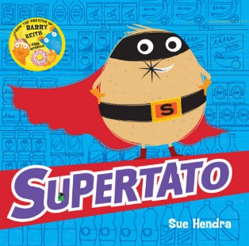  EYFS: “Supertato” by Sue Hendra.  Meet Supertato! He's always there for you when the chips are down. He's the superhero with eyes everywhere - but now there's a pea on the loose. A very, very naughty pea. Has Supertato finally met his match? |  | 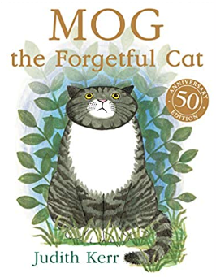  KS1: “Mog the Forgetful Cat” by Judith Kerr.  Everyone’s favourite family cat first appeared fifty years ago and is loved by children everywhere for her funny and warm-hearted escapades. The classic picture book story of a very forgetful cat, her family, and a very exciting adventure is a great read for families, boys, girls, and anyone who has ever known or loved a cat.
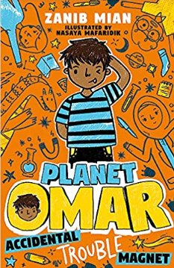  Year 3/4: “Planet Omar – Accidental Trouble Magnet” by Zanib Mian.  My parents decided it would be a good idea to move house AND move me to a new school at the same time. As if I didn't have a hard-enough time staying out of trouble at home, now I've also got to try and make new friends. What's worse, the class bully seems to think I'm the perfect target.  At least Eid's around the corner which means a feast (YAY) and presents (DOUBLE YAY). Well, as long as I can stay in Mum and Dad's good books long enough... |  | 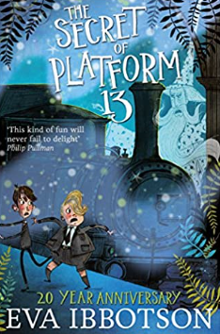  Year 5/6: “The Secret of Platform 13” by Eva Ibbotson.  Under Platform 13 at King's Cross Station there is a secret door that leads to a magical island . . .  It appears only once every nine years. And when it opens, four mysterious figures step into the streets of London. A wizard, an ogre, a fey and a young hag have come to find the prince of their kingdom, stolen as a baby nine years before. But the prince has become a horrible rich boy called Raymond Trottle, who doesn't understand magic and is determined not to be rescued.
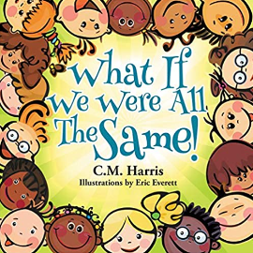  KS1 NON – FICTION: “What if we were all the same!” by CM Harris.  What If We Were All The Same! embraces all of our wonderful differences. Whether you have red hair or brown hair, green eyes or blue eyes, long legs or short legs, light skin or dark skin, glasses, uses a wheelchair or anything else, it's absolutely OKAY! Our differences are what makes us unique and if we truly think about it, would you want to be the exact same as someone else? |  | 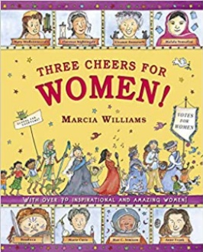  KS2 NON – FICTION: “Three Cheers for Women” by Marcia Williams.  Join Marcia Williams as she celebrates incredible women from around the world and throughout history. From writers to warriors and astronauts to activists, discover their awesome stories and be amazed by their achievements. Marcia Williams' much-loved comic-strip style will encourage even the most reluctant reader to enjoy this inspirational book packed with facts, quotes and jokes.

