What do these keys do?
Cut out and stick the short descriptions at the end of the line that points to the correct key on the keyboard.

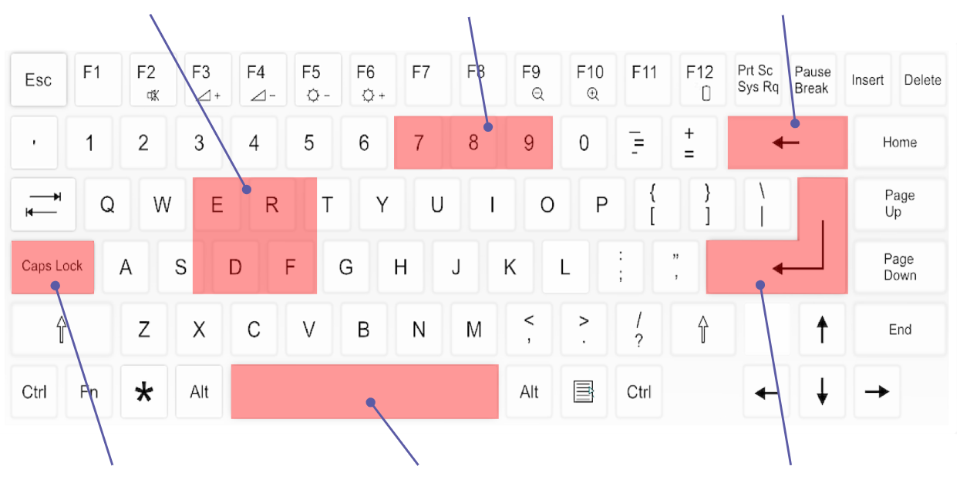

Cut out and stick the short descriptions at the end of the line that points to the correct key on the keyboard.

Adds a space

Adds a letter

Letters are typed as capital letters

Takes away text

Moves down a line

Adds a number

Image source: https://pixabay.com/vectors/computer-keyboard-home-computer-158770/

This resource is available online at ncce.io/cm1w-3-a3-w. Resources are updated regularly — please check that you are using the latest version.
This resource is licensed under the Open Government Licence, version 3. For more information on this licence, see ncce.io/ogl.

