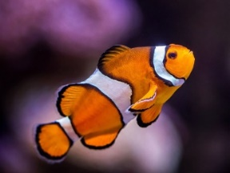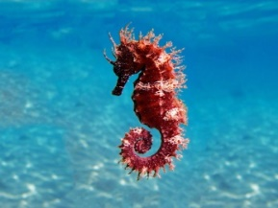

Welcome back to Term 5 in Key Stage 1!

Dear Parents and Carers,

This term our Key Stage 1 topic is “Ready Steady Grow!” Our cross-curricular learning stems from Science and Geography and will promote writing and maths across all subjects. We will be using every opportunity to get outdoors and explore our environment and it’s potential for growing.

English
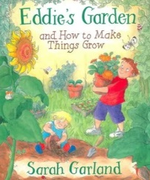
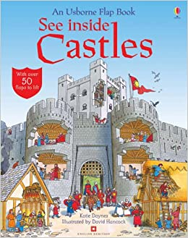
This term our class texts are “Eddie’s Garden and How to Make Things Grow” by Sarah Garland and “Growing Good” by Bernard Ashley. They
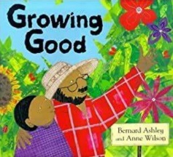
will provide the basis for our writing, which will include instructions and stories with familiar settings.
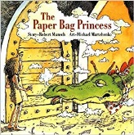
Please take the time to read the attached information as it gives an outline of how you can use this approach to support reading at home by asking meaningful questions about the text. The questions are not limited to reading times; they can also be used when you watch television or a film, as well as everyday discussion.
You can access additional books in the Reading Eggs library.
How You Can Help
- Read with your child every day and talk to them about what they are reading. Ask them questions about the story, characters and plot.
- As part of their learning at home or at school, every child should be doing Reading Eggs for 15 minutes at least 3 times a week. There is also Fast Phonics which should be done in addition to the reading times.
- Make up stories, take photos, draw pictures and use puppets to re-tell them.
- Read a variety of texts including Nursery Rhymes and Fairy Tales.
- Discuss the parts of the book with your child e.g. front cover, blurb, author, illustrator.
- Visit the Library and listen to audiobooks.
- Non-fiction texts are available in many formats. Can you find different examples of non-fiction and see the different ways that they can be presented?

Maths
In Maths this term KS1 are learning about fractions and position and direction.
Please continue to support your child in learning to count in steps of 1, 2, 5 and 10. By the end of Key Stage 1, most children should have rapid recall of their 10x, 5x, 2x and 3x tables.
How You Can Help
- Use everyday opportunities to talk about and use maths, e.g. ‘How many knives and forks do we need for dinner?’ ‘The biscuits will be ready in 12 minutes. What time is it now? What time will they be ready?’
- Practise number bonds to 10 and 20, and then 100.
- Encourage your child to become more fluent in addition and subtraction using numbers up to and across the 100 threshold.
- Practise splitting objects (fruit, cakes, pizza) into halves and quarters; ‘Why must each part be the same?’ Then move on to splitting amounts e.g. ‘What is half of 10? ‘What is a quarter of 20?’ You could use counters, dry pasta or any objects you have to hand to practise.
- Practise using position and direction words: forwards, backwards, left, right, clockwise, anti-clockwise.
- Begin learning the 10x, 5x, 2x and 3x tables off by heart.
- Telling the time. Make sure that your child can read the o’clock, half past, quarter to and quarter past times on an analogue clock.
- Help your child to learn to tell the time to the nearest 5 minutes, on analogue clock faces.

PE
PE will be on either Wednesday or Thursday afternoons according to your child’s class, this has been shared with you via Class Dojo but please check with your child’s class teacher if unsure. As last term, children should wear their PE kits to school. All uniform should be named so that any items can be returned easily.
Homework
Homework is set every Friday; homework books must be returned by the following Thursday at the latest. Please support your child to complete their homework.

Spellings are set on a weekly basis, and there is a daily expectation for children to read aloud.

We have received positive feedback of the homework task sheet. We ask that you support your child to choose one activity to complete weekly. Please date and tick the sheet to indicate they have been done. We love reading the children’s home learning and you are more than welcome to share photographs of their work on Class Dojo. There are further home-learning ideas for this term’s topic attached to this letter. This is optional, but the children really enjoy being able to show and tell us about what they have made at home.

New for this term: there will be a weekly task set on Reading Eggs and Maths Seeds for your child to complete.
Water bottles and snacks
A hydrated brain is essential to learning! Please ensure that your child brings in a named water bottle. All key-stage one children are offered a healthy snack each day.

As always, please do not hesitate to contact us if you have any questions or queries. Thank you for your continued support.
Mrs Leigh, Miss Brewster and Miss Birkby
The Key Stage 1 Team.
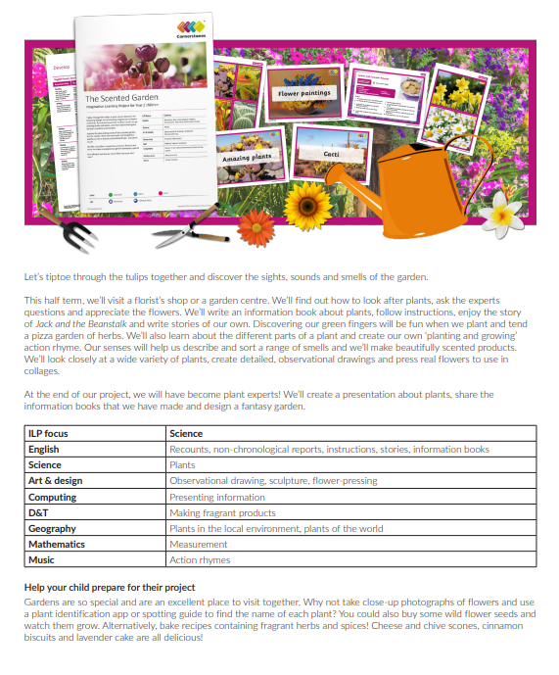

These are additional, optional activities. They are also a useful alternative if your child finds the topic learning challenging.

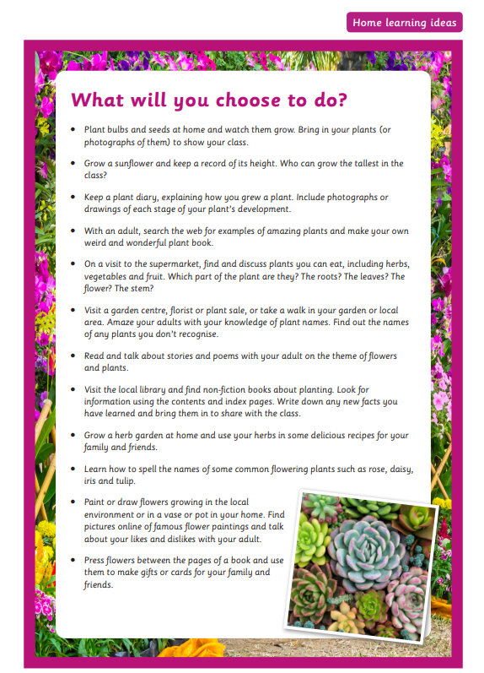

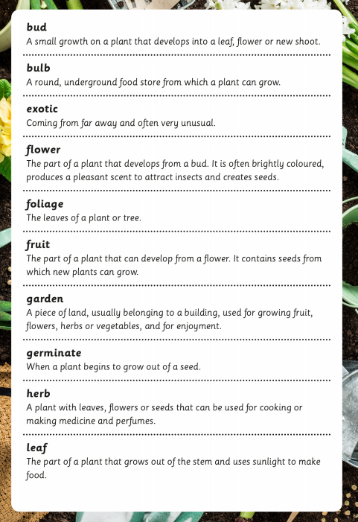

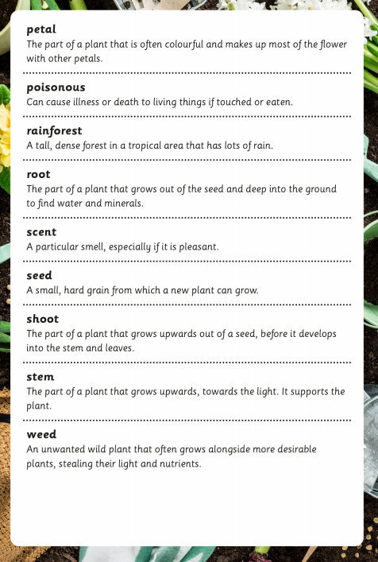

These are useful question stems that support one-to-one reading time at home.

