7th November 2017

Dear Parents

Christmas Dinner – Wednesday 13th December 2017
Barracudas, Cuttlefish, Stingrays, Killer Whales, Jellyfish, Marlin, Sharks and Dolphins
The menu for this year’s Christmas Dinner will be:

Main Vegetarian Pudding
Turkey Quorn Roast Christmas biscuit,
Pork Cocktail Sausage in bacon Stuffing Balls Fresh Fruit/Yogurt
Stuffing Balls Roast Potatoes
Roast Potatoes Fresh Carrots
Fresh Carrots Peas
Peas Gravy
Gravy

The cost of the meal for children in Year 3, 4, 5 and 6 is £2.10. Please ensure you return the reply slip and the correct money in a sealed envelope with your child’s name on it and clearly marked ‘Christmas Dinner’. We regret no change can be given.
If you would like to pay via ParentPay please book the meal and save your booking by the 17th November and return the slip below by the deadline. Please ensure that on 13th December you have the funds in your ParentPay account to pay for the meal.

Every child in KS2 must return the reply slip by Friday 17th November if they would like to order a Christmas dinner. The school kitchen needs to know how many meals to provide by this date so they can order the food.
We have been informed by Chartwells that any children who have not ordered a Christmas dinner by this date will have to bring a packed lunch.

Yours sincerely
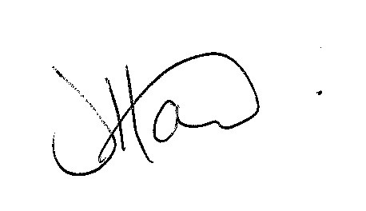
Ms J Howard
Headteacher

**********************************************************************************************************************************
PLEASE RETURN TO THE SCHOOL OFFICE BY Friday 17th November

Child’s Name …………………………………………………………………..

Class ………………………………………………………….
Would like a Turkey Christmas Dinner □
Would like a Vegetarian Meal □
Is entitled to Free School Meals □
I enclose my payment of £2.10 □
I am paying via ParentPay & have booked the meal □
Signed …………………………………………………………………… parent / carer

