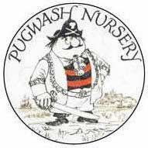
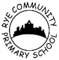Friends of Rye Community Primary and Pugwash Nursery

Friends of Rye Community Primary and Pugwash Nursery will be having its AGM in the school hall on Thursday 20th October at 4.30pm, just before parents’ evening. Please note that the date published on our earlier flyer (the 19th) is no longer correct.
We will be confirming our new committee members and our revised constitution, as well as the charities we will be supporting for the next year. There will also be plenty of information on what we have been up to in the last year and what we have planned for this year. So, whether you would like to become a Class Rep or you would just like to find out what we are up to, everyone is very welcome to come along.
The meeting will be quite short and we will do our very best to get the boring bits finished as quickly as possible but if anyone would like to see the revised constitution before the meeting, copies are available from the school office.
We have already been contacted by some parents and carers who are interested in becoming Class Reps but we would love to hear from everyone who is interested.
If there is anything you would like to ask us, please speak to Sophie, Lindsay, Charmaine or Jon in the playground, leave your details at the school office, email us at friends@ryeprimary.co.uk or phone or text us on 07983 574528.
Kind regards,
Your PTA

