11th October

Dear Parent / Carer

Re: Parent Evenings
Tuesday 18th October 3.30 – 5.00p.m.
Thursday 20th October 4.00 – 7.00p.m.

We will be holding parents evenings on the dates above, and hope that you will be able to come along to meet with your child’s teacher.

In order to book your appointment, we will have class lists in the foyer each morning and afternoon from Wednesday 12th October. Please write your name against an appointment time. Children in Years 5 and 6 may sign up on behalf of their parents. If your child travels to school on the bus, please send a note into your child’s class teacher.

If your child is part of the Achievement for All (AfA) project, then your child’s class teacher will have contacted you to make an appointment to attend a structured conversation, therefore there is no need to make parents evening appointment.

We look forward to seeing you all on either 18th or 20th October and encourage you to bring along your e-mail login details, because, as you know we always consider your opinions and suggestions and would like you to access Parent Views whilst you are here. If you have already registered, then please remember to bring your password with you. This is a valuable tool for gathering your views.

Yours sincerely

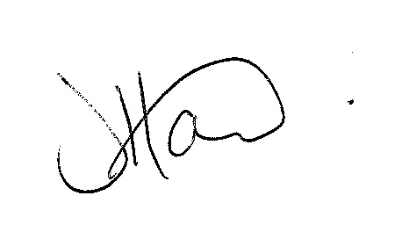

Ms J Howard
Headteacher

