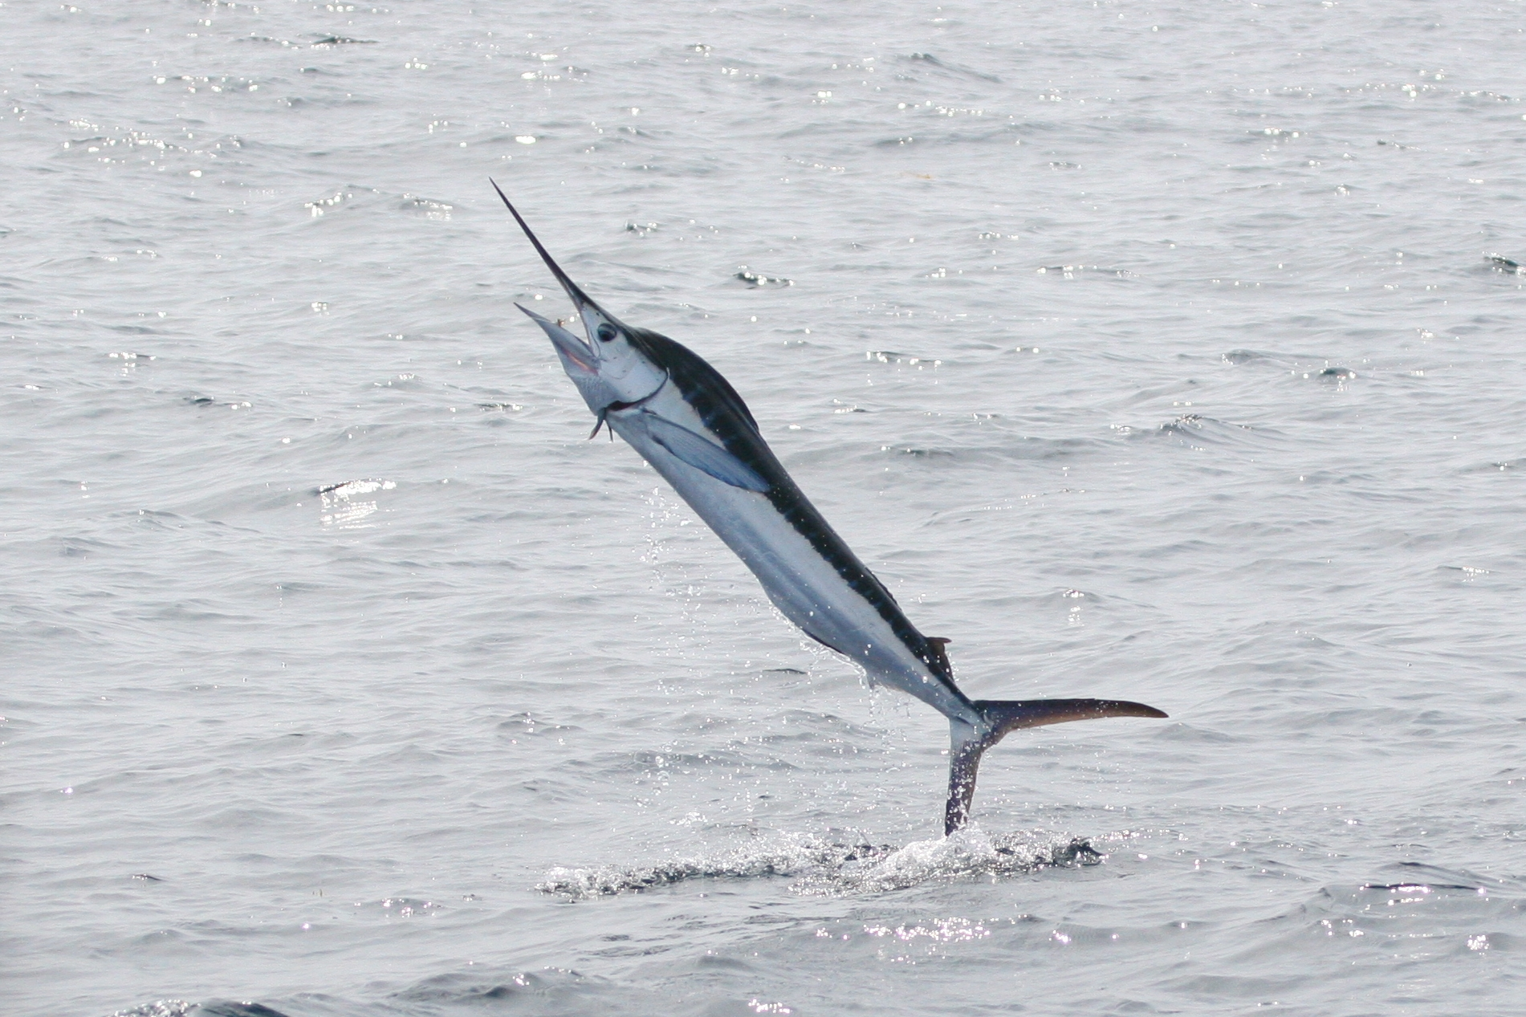

Dear Parent Marlin

Happy New Year to you all! We hope that you enjoyed the festivities and are keen to hear about your child’s learning this term. Last term’s learning about World War 1 and Life in the Trenches was a huge success. Thank you for your support in the making of a special ‘comfort’ box for a soldier – they were very imaginative.

Term 3 Learning in Marlin

‘Cosmic!’ – A study of the Earth, Sun and Moon

Our learning this term will take us into outer space! We will be studying the relationship between the earth, sun and moon and looking closely at the force of gravity. Our learning will require us to collect data over a period of time and use this knowledge to help explain the incredible phenomena that is our world in the solar system.

English

The focus this term will be on writing an adventure story and poetry. Our class book will be ‘Cosmic’ by Frank Cottrell Boyce, a story about a young boy and his adventure into space.
How you can help your child
- Make sure your child reads daily and discuss the stories in terms of your child’s personal reading targets. Don’t forget to record reading sessions in the ‘Greedy Reader’ booklets.
- With the topic in mind, please find out and discuss as much information about Space as possible.
- Discuss meanings of any new vocabulary they come across.
- Practise the spellings that are sent home weekly.

Mathematics

In Maths this term we will be improving our addition and subtraction skills. We will then try to understand the relationships between different types of measures and then reflect shapes in different axes, as well as plot co-ordinates.

How you can help your child
- Look for opportunities to talk about maths in the everyday environment.
- Support your child and give them time to use mental calculations skills in real life contexts.
- Help your child to learn his/her multiplication facts to become a Number Muncher.

PE

PE this term will be taught on Mondays. The focus will be on Dance. Please ensure your child has their PE kit as several children persistently seem to have left it at home.

Termly Homework Project

Use your knowledge of the earth, sun and moon to make a simple 3D model.

If you are feeling really ambitious, then why not include the other planets in the solar system in your model.

Thank you for your support.

If you have any queries do not hesitate to contact me.

Mr MacNicol

