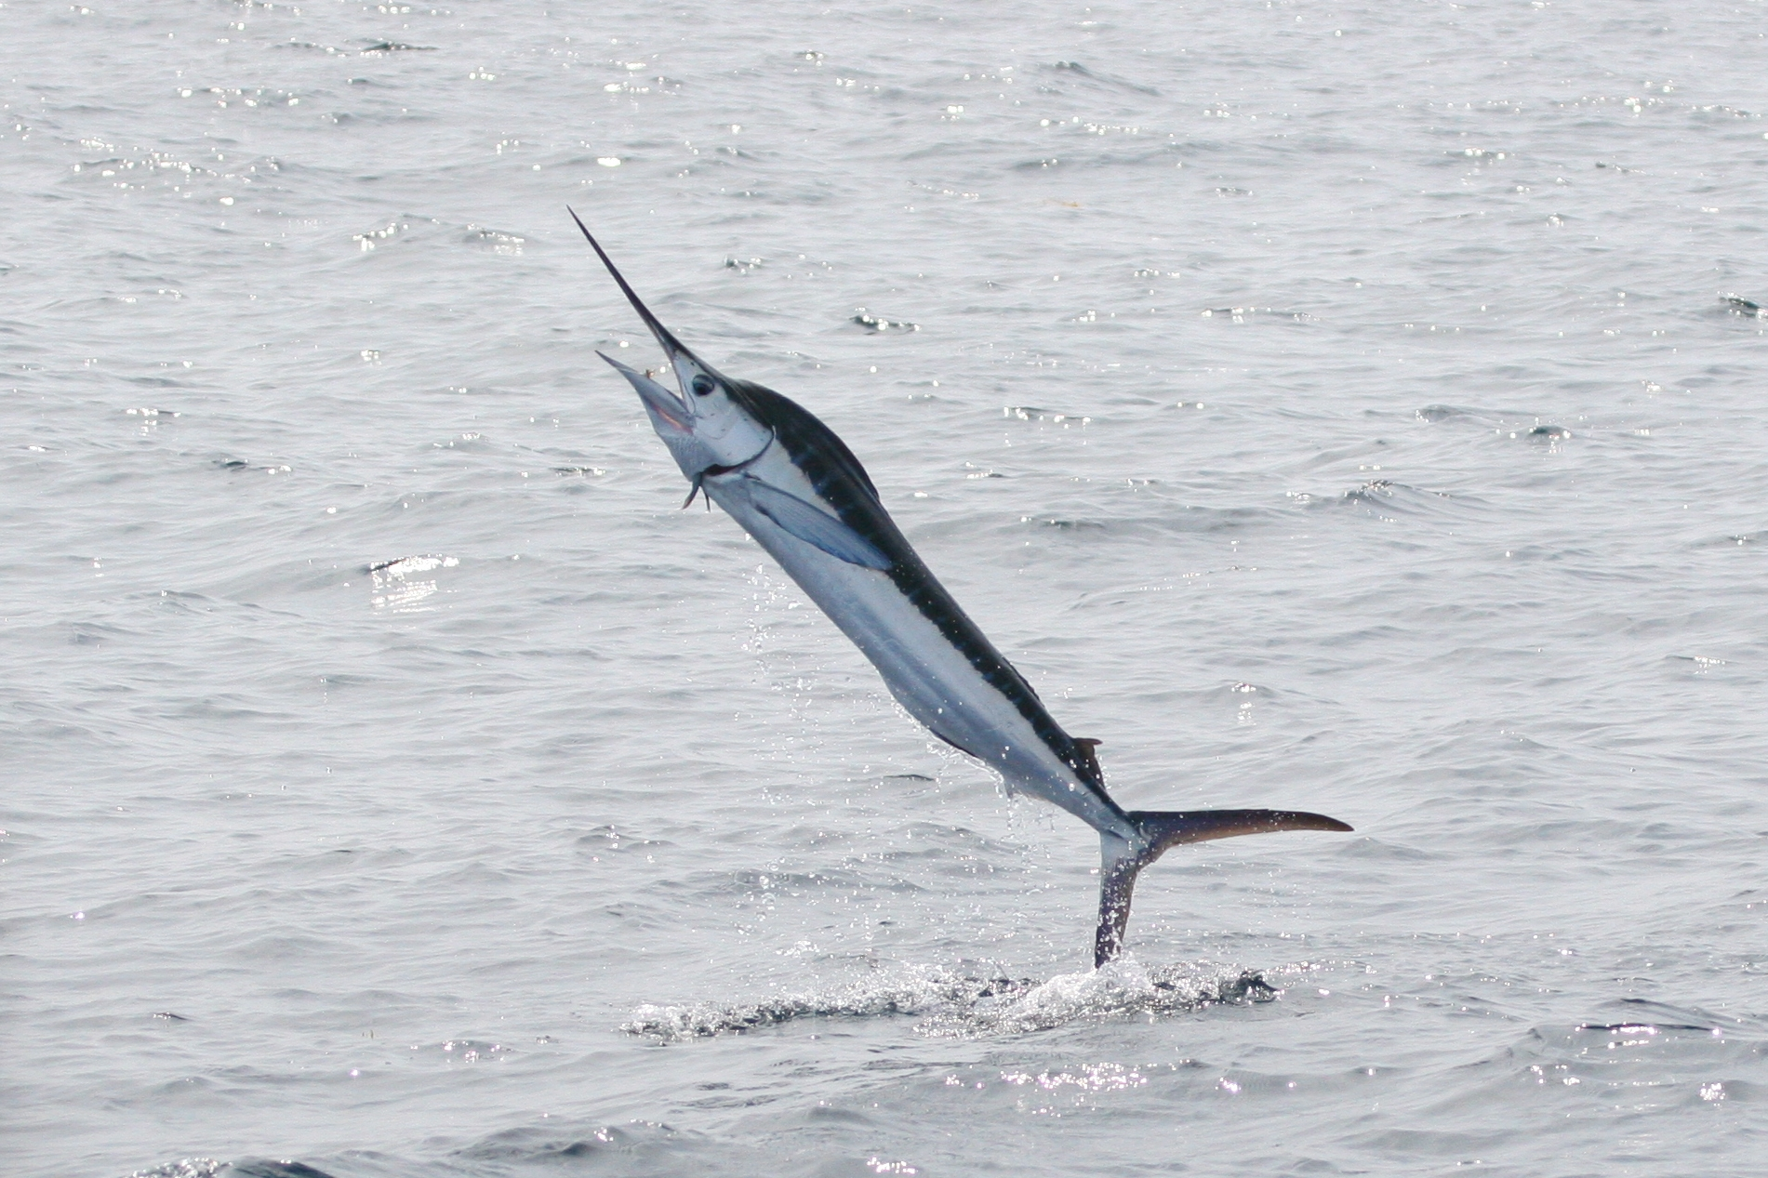

Dear Parent Marlin

I would like to say a huge thank you to you all for your continued support last term. It is lovely to see lots of you visiting us for Words with Wings.

Term 4 Learning in Marlin

A Pocketful of Rye
This term’s learning uses our local area, with a particular focus on smuggling in times gone by. We will learn what smuggling was, where the main meeting points were (including a visit to The Mermaid Inn), as well as what goods were smuggled. We are combining our Science and Design Technology learning this term by looking at pulleys and how they could be used to raise smuggled goods from a beach!

English
The focus this term will be on poetry and suspense story writing with a particular focus on ‘The Smuggler’s Song’ by Rudyard Kipling and ‘The Listeners’ by Walter de la Mare.
How you can help your child
- Make sure your child reads daily and discuss the stories in terms of your child’s personal reading targets. Don’t forget to record reading sessions in the ‘Greedy Reader’ booklets.
- With the topic in mind, please find out and discuss as much information about the history of smuggling in Rye.
- Discuss meanings of any new vocabulary they come across.
- Practise the spellings that are sent home weekly.

Mathematics
This term we are extending our learning about fractions by now adding and subtracting them. We will then continue to challenge ourselves by multiplying them! After this learning we will be solving word problems before studying statistics.
How you can help your child
- Look for opportunities to talk about maths in the everyday environment.
- Make sure that your child is able to tell the time using an analogue clock.
- Support your child and give them time to use mental calculation skills in real life contexts.
- Help your child to learn his/her multiplication facts to become a Number Muncher.

PE
PE this term will be taught on Wednesdays. Please ensure your child has the correct PE kit as several children have no plimsolls or trainers.

Words with Wings
We are looking forward to seeing you at our Words with Wings reading sessions on a Friday afternoon. These will begin at 2.30pm and are an opportunity for you to share some reading books with us.

Sharing Assembly
Unfortunately, we do not have a sharing assembly this term however we are sure that the children would love to share their learning with you at home.

Trainee Teacher
This term we are lucky enough to still have Megan Lynn with us, a third year trainee teacher from Christ Church University, helping to support our learning. Megan is currently completing her final placement and will be planning and teaching in conjunction with myself to ensure that all the children’s individual needs are met.

Termly Homework Project

Design a ‘WANTED’ poster for the arrest of Dr Syn.
It will need to include:
- a picture of him,
- why he is wanted,
- who to report him to,
- what the reward will be.

Thank you for your support.
If you have any queries do not hesitate to contact me.

Mrs Kearney

