Monday 11th January 2021
LI: To explore language for poetry.
Steps to Success:
- I recite poems by heart. (Band 1 Reading)
- I join in with predictable phrases when being read to. (Band 1 Reading)
- I am beginning to build up a repertoire of poems, learnt by heart. Recite these with understanding and use of intonation. (Band 2 Reading)
- I am beginning to develop stamina for writing by planning and writing poetry. (Band 2 Writing)

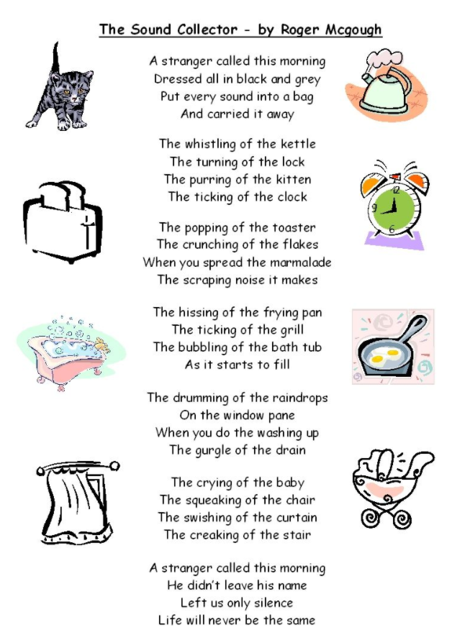

Questions to help you:
- What is happening in the poem?

- Can we guess how the poet is feeling?
Talking about the poem
- Do you notice any patterns? What else do you notice? E.g. Is there rhyme, repetition, alliteration?
- Do you like the poem? Why/why not?
- What do you like the sound of? How would you feel if it was suddenly taken away?

Later in the week you are going to write your own sound collector poem. Use this space to write down your ideas.
My Word Bank
Things I like the Sound of | Wow words (adjectives I can use to describe and add detail)

Performing
Can you perform the poem, with actions to someone in your family?
Remember:
A clear, loud voice using expression.
Face the audience.
Keep any paper away from your face.

Note to parents: This unit of learning explores and develops language through poetry. This lesson is designed to motivate language and ideas as much as possible. Please follow the PowerPoint which includes the relevant video. As language is key in this lesson, please feel free to support writing as much as you think is best.

