11.01.2021 Level 1
LI: To subtract 2 numbers.
Steps to success:
- I can solve number problems by subtracting numbers up to 10. (Level 1)
- I can solve number problems by subtracting 1 and 2 digit numbers. (Level 2)
- I solve number problems with subtraction by writing the sums in different ways. (Level 3)
Reasoning and problem solving: can you explain your answers?
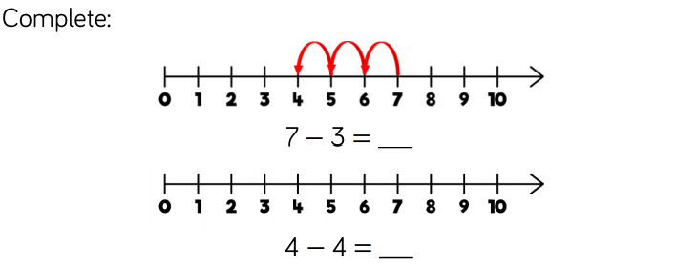

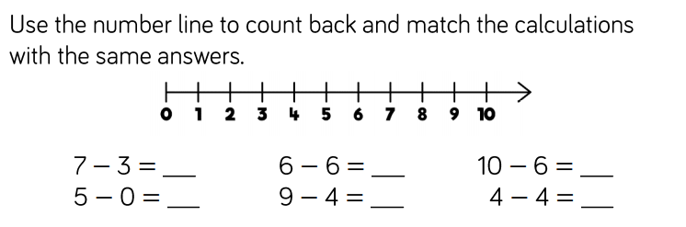

Can you think of any other number sentences that would give the same answers?

Here is a numberline to help you.

My number sentence

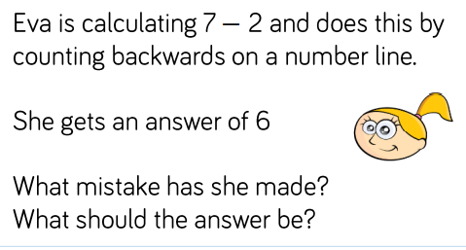
4.

