11.01.2021 Level 2
LI: To subtract 2 numbers.
Steps to success:
- I can solve number problems by subtracting numbers up to 10. (Level 1)
- I can solve number problems by subtracting 1 and 2 digit numbers. (Level 2)
- I solve number problems with subtraction by writing the sums in different ways. (Level 3)
Reasoning and problem solving: can you explain your answers?

- 17 – 3 = 14- 4 =

Here is a numberline to help you.

- Use the numberline to count back and match the calculations with the same answers.

17 – 3 = 17 – 13 = 16 – 6 = 16 – 16 = 20 – 16 = 20 – 6 = 15 – 0 = 15 – 15 =
19 – 14 = 19 – 4 = 20 – 15 = 20 – 5 =

Can you think of any other number sentences that would give the same answers?

- I count backwards from 19. How many steps does it take to get to two? Show this in a number sentence.

Here is a numberline to help you.

My number sentence

- Eva is calculating 17 – 2 and does this by counting backwards on a number line. She gets an answer of 16.
What mistake has she made?
What should the answer be?

- The answer is 2
How many ways can you get to this by counting backwards on the number line?

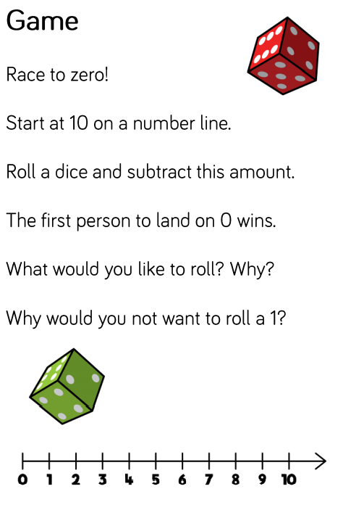
20

