13.01.2021 Level 1
LI: To find the difference between two numbers
Steps to success:
- I can find the difference by solving problems using numbers up to 10. (Level 1)
- I can find the difference by solving problems using 1 and 2 digit numbers. (Level 2)
- I can find the difference by solving problems using the most efficient method to help me. (Level 3)
Reasoning and problem solving: can you explain your answers?

Remember! Think about the most efficient method to use. Will it be easier to count on or count back?

What is the difference between?
1
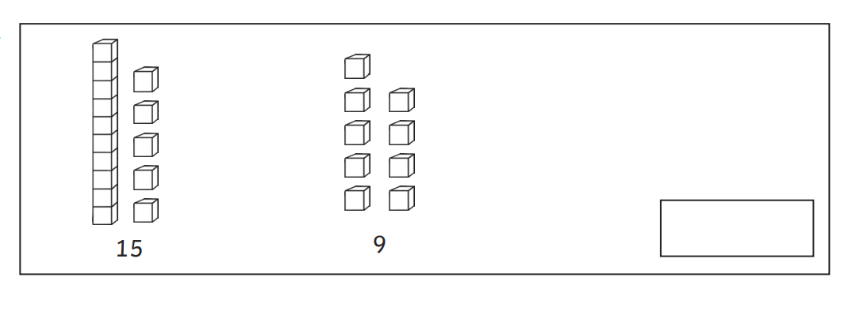

2
What is the difference between?
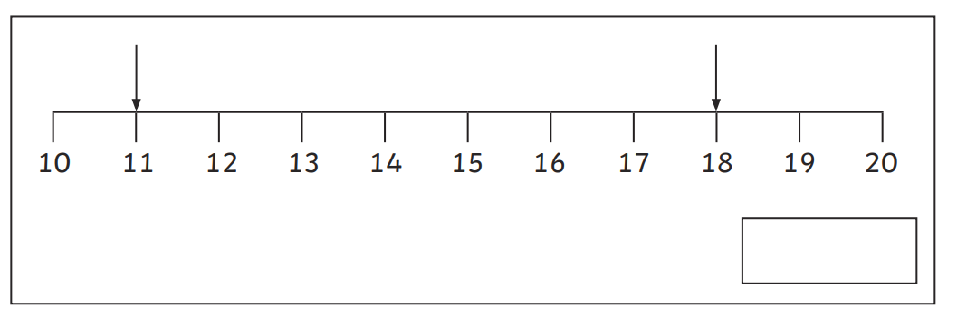

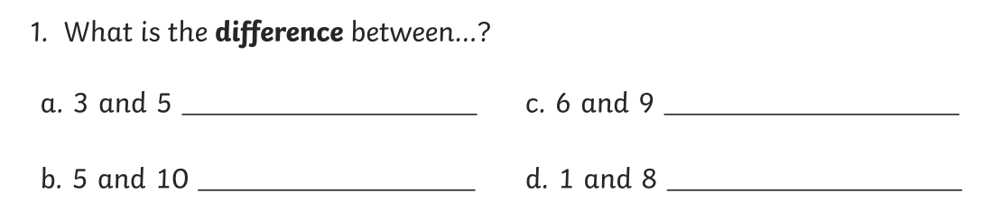
3

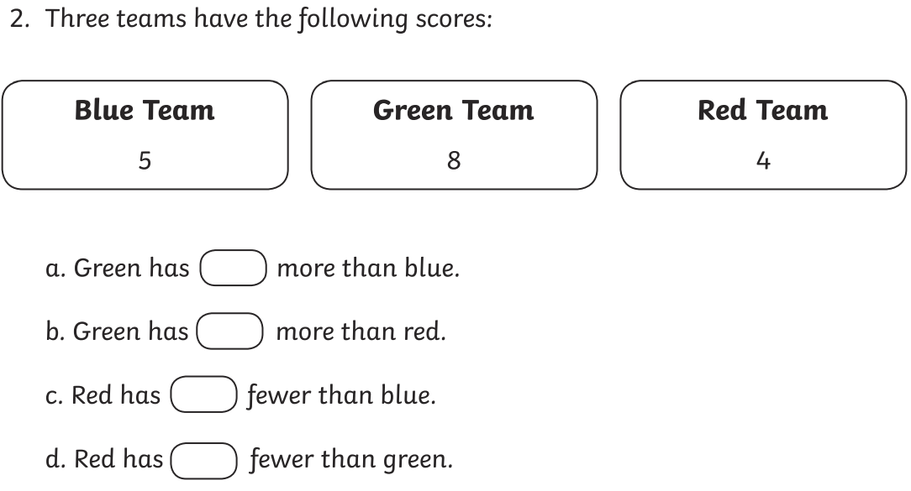
4

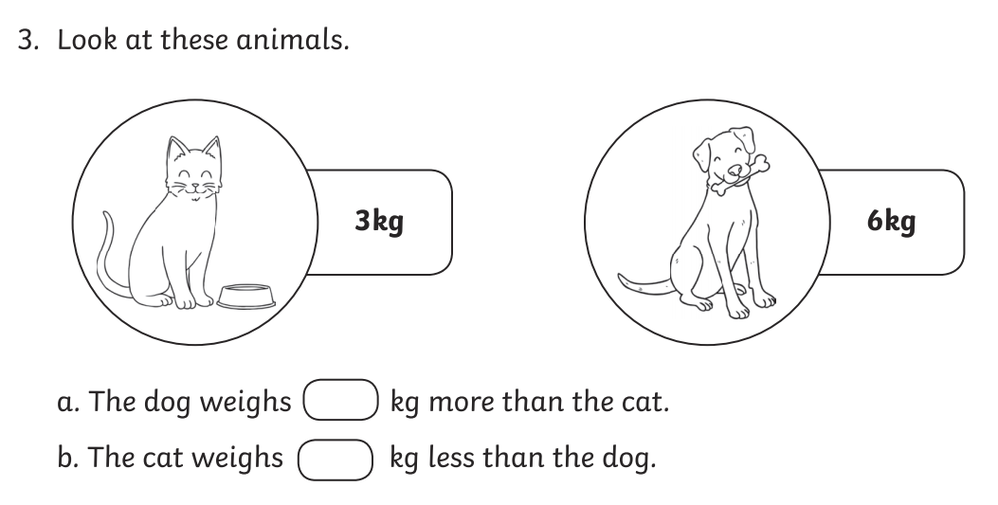
5
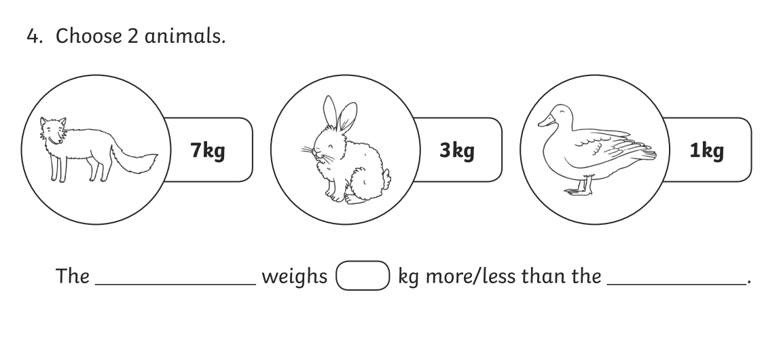

6

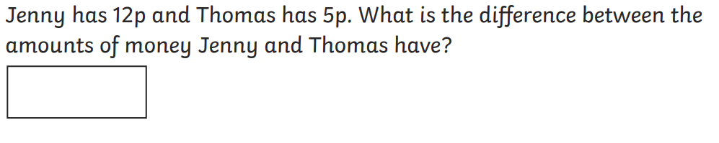

7

8

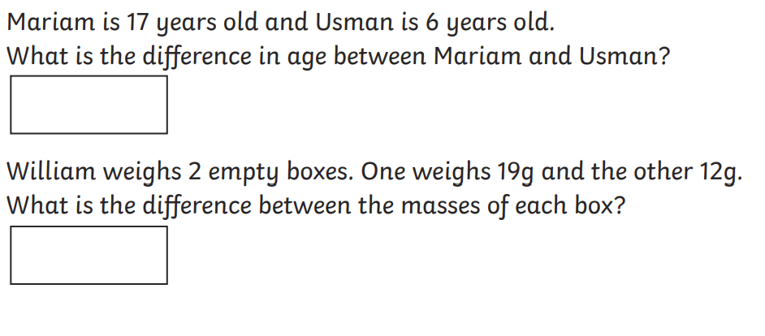
9

