13.01.2021 Level 3
LI: To find the difference between two numbers
Steps to success:
- I can find the difference by solving problems using numbers up to 10. (Level 1)
- I can find the difference by solving problems using 1 and 2 digit numbers. (Level 2)
- I can find the difference by solving problems using the most efficient method to help me. (Level 3)
Reasoning and problem solving: can you explain your answers?

Remember! Think about the most efficient method to use. Will it be easier to count on or count back?

What is the difference between?
1
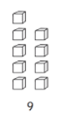

35

2
What is the difference between?

What is the difference between…?
3

- 33 and 45 _____ c. 56 and 79_____

- 65 and 81_____ d. 47 and 62_____

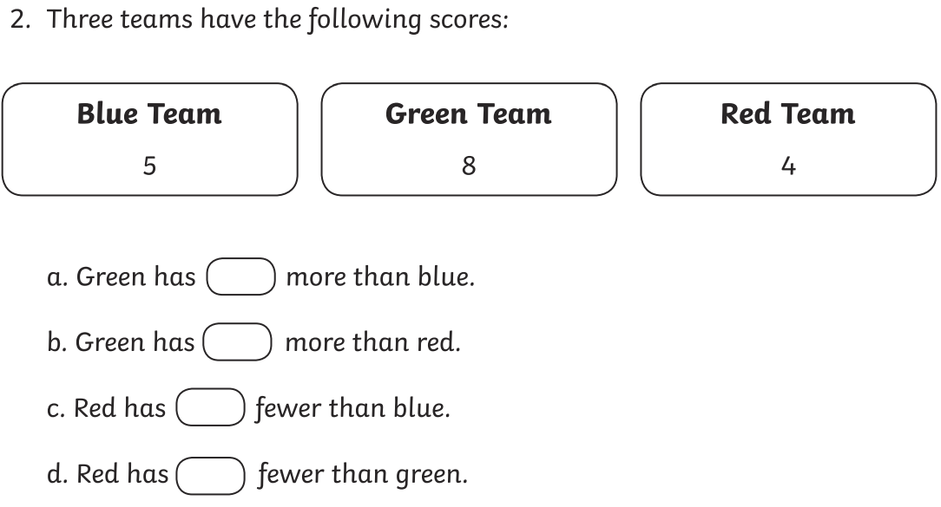
4

24
48
35

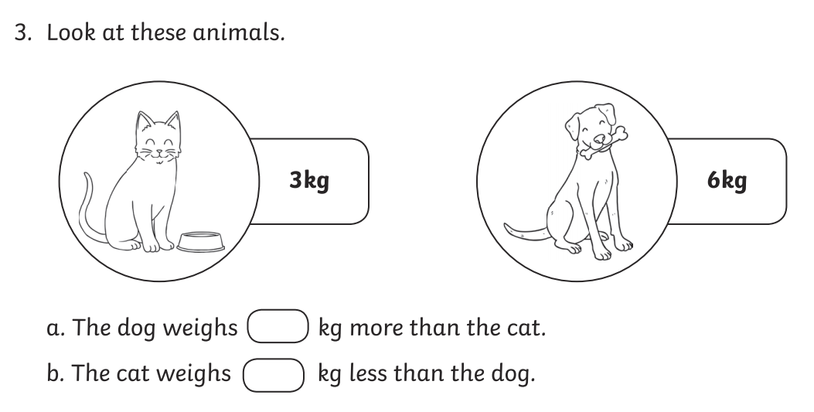
5
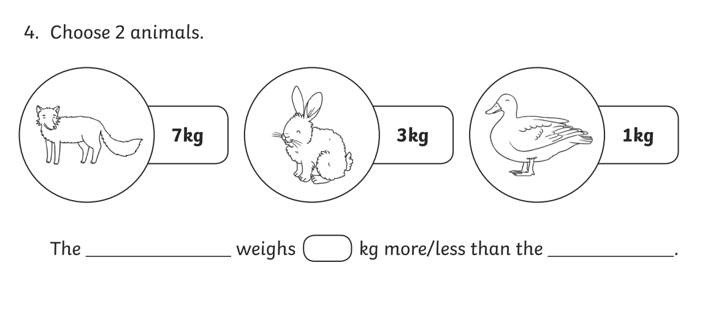
56
33

6
Jenny has 72p and Thomas has 25p. What is the difference between the amounts of money Jenny and Thomas have?

7

31
23
47

8
Mariam is 27 years old and Usman is 6 years old. What is the difference in age between Mariam and Usman?

9

William weighs 2 empty boxes. One weighs 49 grams and the other 22g. What is the difference between the masses of each box?

