OPERATION GAME
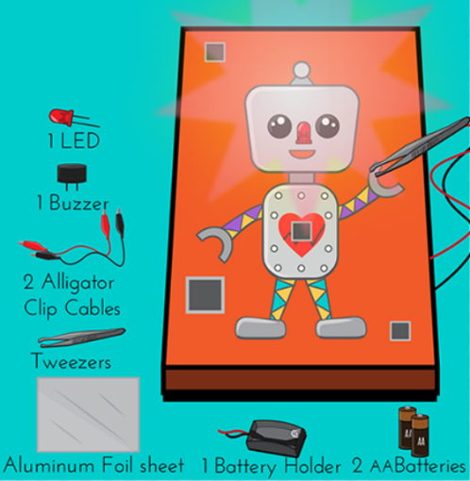
Materials and Tools:
- 1 battery holder
- 1 3V buzzer
- 1 LED or lightbulb
- Aluminium foil
- 2 AA batteries
- Alligator clip cables
- Tweezers
- Cardboard
- Scissors
- Pencil to draw with
- Feltip pens to colour
- Tape
- Instructions for building the circuit

OPERATION GAME - EXPLORE AND INVESTIGATE

What is the aim of the game?

Who is the game for (age, gender, interests)

How do you think the game works?

What do you like best about the game?

OPERATION GAME - PLAN AND DESIGN SHEET

Company name: ______________________________________________________________

Company directors: __________________________________________________________

Body parts: Body parts: Body parts:

______________________ ______________________ ___________________ ______________________ ______________________ ______________________
______________________ ______________________ ______________________
______________________ ______________________ ______________________
______________________ ______________________ ______________________

Audience: Audience: Audience:
______________________ ______________________ ___________________ ______________________ ______________________ ______________________
______________________ ______________________ ______________________
______________________ ______________________ ______________________
______________________ ______________________ ______________________

OPERATION GAME – TEST AND EVALUATION SHEET

Things that went well:

My favourite parts are:

Even better if:

Things we have learned:

