

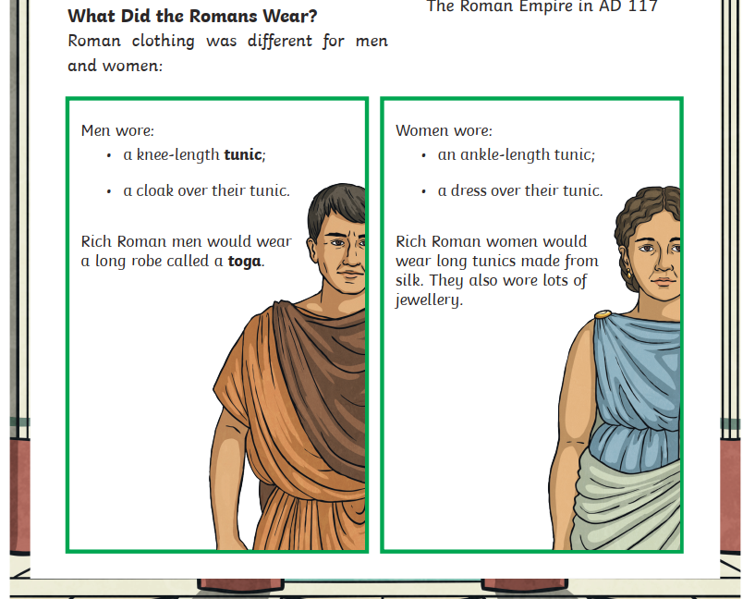

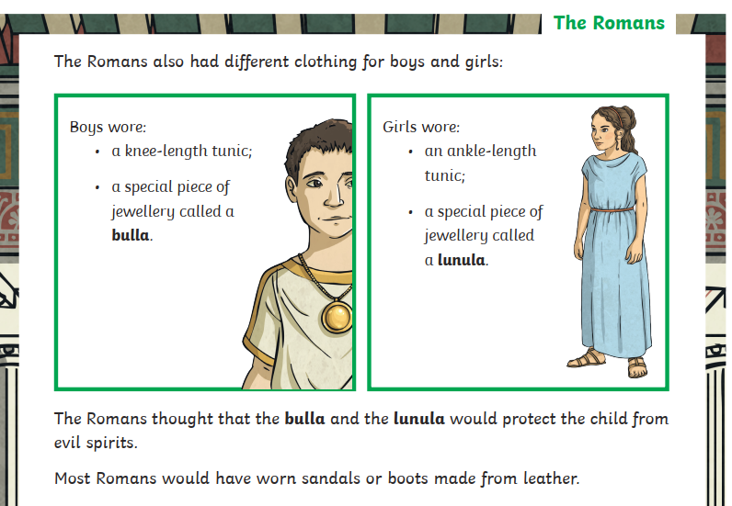



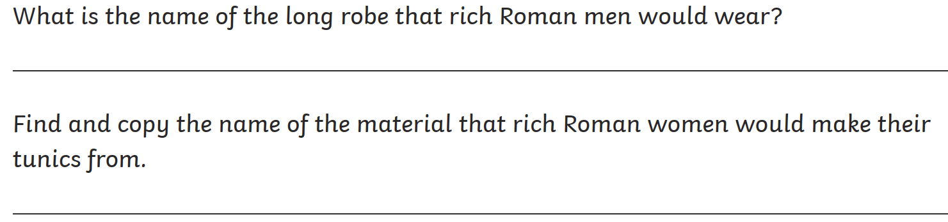

What did the Romans think that the bulla and the lanula would do?

___________________________________________________________