Art – Can I create a mosaic?
At school we would have been making our own mosaics using clay. If you don’t have clay at home you can make salted bread dough and paint your tiles once dry (recipe below).
Don’t worry if you don’t have enough flour and salt. You can have a go at making your own mosaic with things in your house. (Please ask a grown up to help you find what you need and DON’T just help yourself!)
You could use dried beans, pasta, lentils, rice, plastic beads etc
Here are some pictures for inspiration.
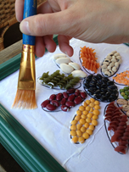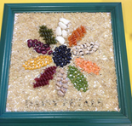

Salt dough recipe
Makes 1 ball
Prep 10 minutes
Cook 3 hours
- 1 cupful of plain flour (about 250g)
- half a cupful of table salt (about 125g)
- half a cupful of water (about 125ml)

Method
1. Preheat the oven to its lowest setting and line a baking sheet with baking parchment.
2. Mix the flour and salt in a large bowl. Add the water and stir until it comes together into a ball.
3. Transfer the dough to a floured work surface and shape into small squares.
4. Put your finished items on the lined baking sheet and bake for 3 hrs or until solid.
5. Leave to cool and then paint.

