Homework task

Introduction
Today we have looked at how words and pictures are used on signs in the world around us. Your task is to look at some examples of packaging and see if you can find examples where images, text, or both images and text have been used to communicate a message.

Draw or stick examples in the table below and label them, or display your work in your own way. Look at the example on the next page to get some ideas.

Images | Text | Images and text

Examples of images | Examples of text | Examples of images and text
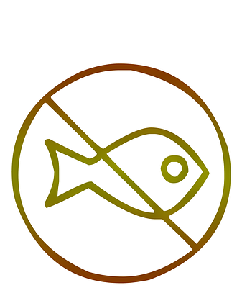  Seafood-free  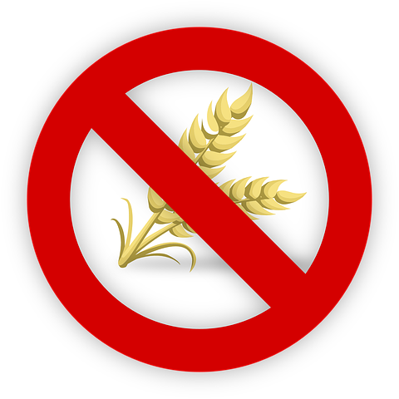  Gluten-free or wheat-free | 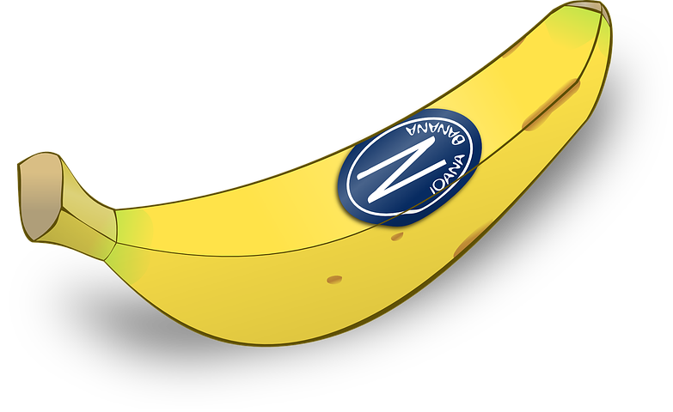  Stickers on fruit often say where it came from, or the name of the company  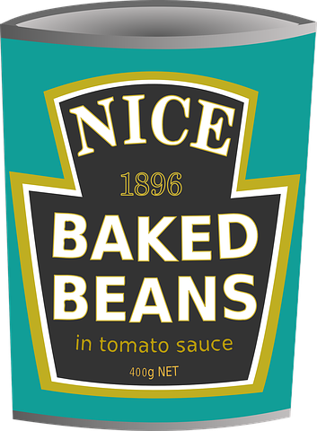  The baked beans label tells you what is in the can and when they were first made by the company | 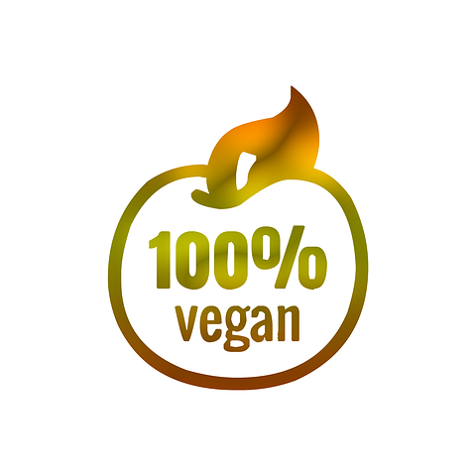  Vegans can eat this

This resource is available online at ncce.io/cm3d-1-w. Resources are updated regularly — please check that you are using the latest version.
This resource is licensed under the Open Government Licence, version 3. For more information on this licence, see ncce.io/ogl.

Fish: http://cdn.pixabay.com/photo/2018/05/03/23/42/vegan-3372843__480.png
Wheat/gluten allergy: http://cdn.pixabay.com/photo/2015/10/18/19/12/wheat-995055__480.png
Banana: http://cdn.pixabay.com/photo/2012/04/13/14/06/banana-32535__480.png
Beans: http://cdn.pixabay.com/photo/2013/07/12/17/11/baked-beans-151747__480.png
Vegan apple: http://cdn.pixabay.com/photo/2018/05/03/23/41/vegan-3372841__480.png

