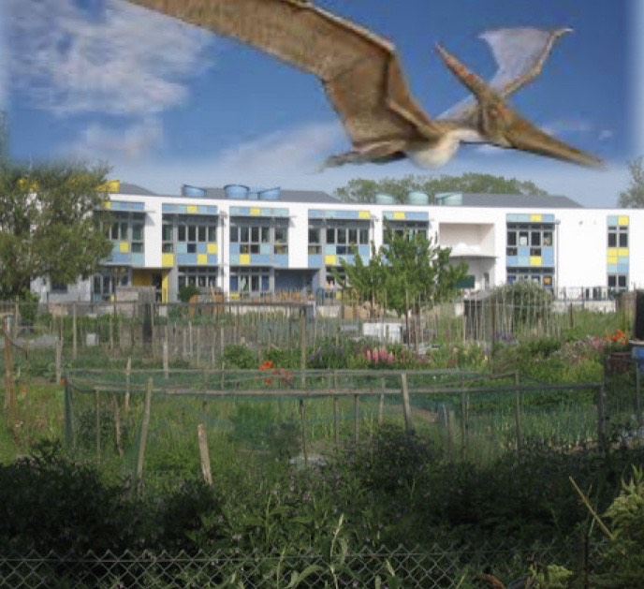

Rye Writers
Please create a ‘missing’ poster for this dinosaur that was found flying above the school, focusing on the description. Remember to include adjectives, adverbs, and a simile, metaphor or personification. Good Luck!

