**Vocabulary for setting:**

**Problem (who/what might you find on this journey? What is the main event that takes place?):**

________________________________________________________________________________________________________________________________________

**Characters:**

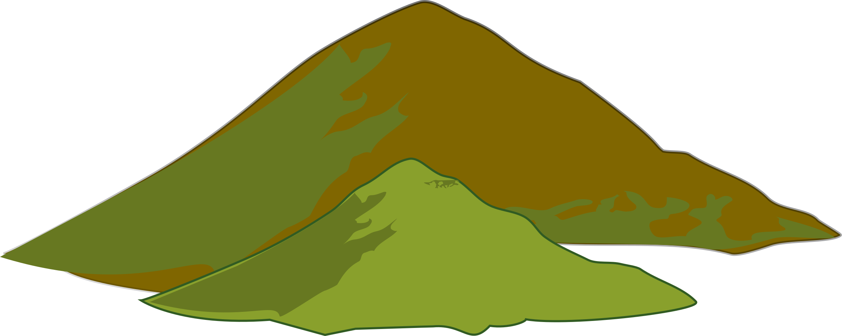

**Ending (ensure all the questions have ben answered for your reader):**

________________________________________________________________________________________________________________________________________

**Resolution (how is your ‘problem’ solved?)**

________________________________________________________________________________________________________________________________________

**Build Up (what leads you to find the pathway?):**

________________________________________________________________________________________________________________________________________

**Introduction (set the scene/introduce your main character):**

________________________________________________________________________________________________________________________________________

Story Mountain