Maths  Mon-Fri  Should be done in order | Daily counting from any number forwards and backwards. Counting in 2’s, 5’s and 10’s Practise writing numbers 1-20 in words.
 | Monday  Activity 1: Days of the week.  Activity 2: Yesterday, today, tomorrow.  All work sheets can be found below this table on the web page. | Tuesday  Look through the powerpoint.  Activity 1: Months of the year.  Activity 2: Months and seasons. | Wednesday  Sequencing the times of the day.  Activity: Match the activity to the part or parts of the day when it might usually happen. | Thursday  Counting in 2’s, 5’s and 10’s  Activity: Counting in 2’s, 5’s and 10’s sheet. | Friday  Problem Solving  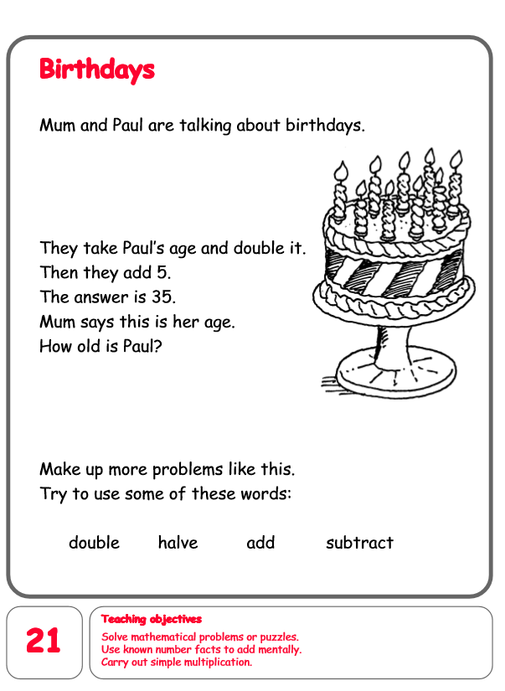
English  Mon-Fri  Choose one-a-day. | Daily Reading, Phonics ( Practise Phase 3 and Phase 5 sounds) and spelling practice ( Spellings- Common exception words and the days of the week ) Phonics game 2DO task on Purple Mash
 | Retelling the story  Listen to We’re going on a lion hunt again.  https://www.youtube.com/watch?v=ECYiUsppM14  Activity: Children to retell the story using time connectives. (first, next, then, after that, finally)  e.g  First the girls walked through the grass.  Next they splashed through the lake. | Grammar, Punctuation and Spelling  Using a sentence.  Read through the powerpoint.  Then complete worksheets. | Comprehension  All about leopards.  https://content.twinkl.co.uk/resource/f8/dc/t-l-52285-year-2-leopards-differentiated-reading-comprehension-activity_ver_6.pdf?__token__=exp=1591030655~acl=%2Fresource%2Ff8%2Fdc%2Ft-l-52285-year-2-leopards-differentiated-reading-comprehension-activity_ver_6.pdf%2A~hmac=d72073ea03ec5d357fdef082930eae39ddba997d8fb84318f1a71802f02a8964 | Thursday and Friday  Rye Writers  Rye-Writers is best done on consecutive days. You can also choose when to do the 2 sessions could be on the same day, just do 2 curriculum subjects on the other day.  Complete writing a letter to a resident in a local care home in Rye.  Or write a letter to a friend or family member telling them what you have been doing.
Curriculum  Choose one-a-day. | Science  Life cycle of a butterfly.  Read through the powerpoint.  Activity 1: Life cycle of a butterfly.  You can draw the life cycle or use the activity below. https://content.twinkl.co.uk/resource/6f/0c/t-l-526324-the-cautious-caterpillar-life-cycle-of-a-butterfly-activity-sheets_ver_2.pdf?__token__=exp=1591123110~acl=%2Fresource%2F6f%2F0c%2Ft-l-526324-the-cautious-caterpillar-life-cycle-of-a-butterfly-activity-sheets_ver_2.pdf%2A~hmac=b5e1e5bc73493976b8e2304e22a1cb6aeb14fa70cb9e57d5b030cf1aa6a7556  Activity 2:  Five senses scavenger hunt.  https://content.twinkl.co.uk/resource/57/6b/au-t-3745-five-senses-scavenger-hunt-activity-sheet-_ver_1.pdf?__token__=exp=1591123629~acl=%2Fresource%2F57%2F6b%2Fau-t-3745-five-senses-scavenger-hunt-activity-sheet-_ver_1.pdf%2A~hmac=70a5b86ea3ab04546c9b6c9187ee99c5ba1fe3462d9f48685ada5d9195677dd1 | Geography  To design your own farm map  Activity: Children to make a simple map of their farm showing which animals they would keep and the types of enclosures they would need. Design a simple key to identify these features. | ICT  Purple Mash 2Do Task – 2paint Big Cats. What big cat will you create?  PSHE-  Purple Mash 2Do Task  Can you plan a healthy meal? | Art  Butterfly Symmetry Art  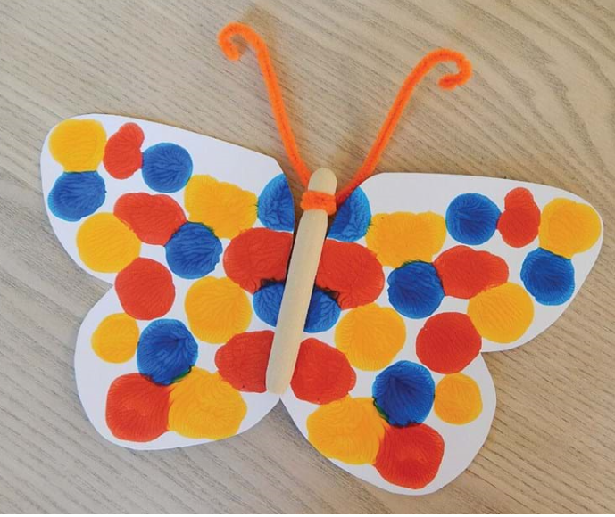  This craft has the wow factor! All you need is paint and some paper. Simply splodge paint on one half of your paper and fold it in half so the paint spreads on both sides. Carefully open it up to reveal a beautiful butterfly.  It's a great way to teach youngsters about butterflies and how their wings are symmetrical. | STEM  Activity 1  Mud face sculptures.  