Maths  Mon-Fri  Should be done in order | Daily counting from any number forwards and backwards. Counting in 2’s, 5’s and 10’s Practise writing numbers 1-20 in words.
 | Monday  Ordering coins  Please look through coin reveal powerpoint.  Activity 1  https://content.twinkl.co.uk/resource/98/ff/t2-m-2290-coin-ordering-cut-and-paste-activity-sheet_ver_4.pdf?__token__=exp=1590956403~acl=%2Fresource%2F98%2Fff%2Ft2-m-2290-coin-ordering-cut-and-paste-activity-sheet_ver_4.pdf%2A~hmac=248e9c13ca12562dcee4f80c50ff0ec2464b0e71cdf8cf2109567e17bf7628d5  Activity 2  https://content.twinkl.co.uk/resource/bf/65/t-n-6208-coin-detectives-activity-sheet_ver_2.pdf?__token__=exp=1590956339~acl=%2Fresource%2Fbf%2F65%2Ft-n-6208-coin-detectives-activity-sheet_ver_2.pdf%2A~hmac=6b97a226db4774b6b55852796501076aea8b782a65b4e5efc6a7366428b2a0fc | Tuesday  Recognising coins  Please look through the powerpoint.  Then complete worksheets.  All work sheets can be found below this table on the web page. | Wednesday  Adding coins  https://content.twinkl.co.uk/resource/01/0e/t-n-1277-how-much-money-is-in-my-piggy-bank-differentiated-activity-sheets_ver_4.pdf?__token__=exp=1590957148~acl=%2Fresource%2F01%2F0e%2Ft-n-1277-how-much-money-is-in-my-piggy-bank-differentiated-activity-sheets_ver_4.pdf%2A~hmac=15a95592f7d6b841c287dc15b22ac377359daf4c2a7af9b2685cc6eba572f174 | Thursday  Counting mixed coins  https://content.twinkl.co.uk/resource/3b/be/t-n-5385-counting-mixed-coins-activity-sheet---_ver_5.pdf?__token__=exp=1590956852~acl=%2Fresource%2F3b%2Fbe%2Ft-n-5385-counting-mixed-coins-activity-sheet---_ver_5.pdf%2A~hmac=1343fe7404937b48d44c1eebca6bf9b09bb9cb7d399ce8b98234d8b6de8f9d9b | Friday  Problem Solving  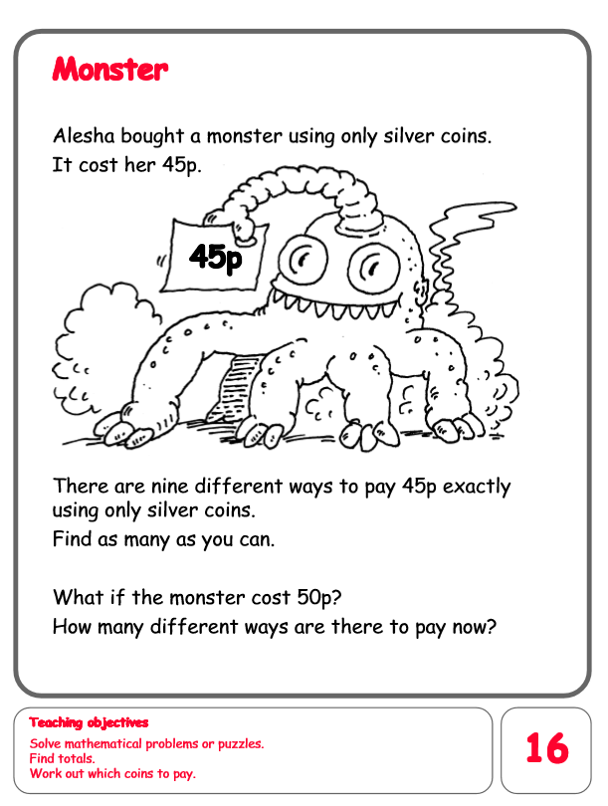
English  Mon-Fri  Choose one-a-day. | Daily Reading, Phonics ( Practise Phase 3 and Phase 5 sounds) and spelling practice ( Spellings- Common exception words and the days of the week ) Phonics game 2DO task on Purple Mash
 | Listen to the story We’re going on a lion hunt.  https://www.youtube.com/watch?v=ECYiUsppM14  Activity: to draw a story map retelling the story, ‘We’re going on a lion hunt’. | Grammar, Punctuation and Spelling  Recognising a sentence.  Please look through the powerpoint.  Then complete worksheets. | Comprehension  All about elephants.  https://content.twinkl.co.uk/resource/44/6a/t-e-2550266-ks1-all-about-elephants-differentiated-reading-comprehension-activity-aged-5-7_ver_3.pdf?__token__=exp=1590953461~acl=%2Fresource%2F44%2F6a%2Ft-e-2550266-ks1-all-about-elephants-differentiated-reading-comprehension-activity-aged-5-7_ver_3.pdf%2A~hmac=3b563ac8fe825d1783c95c26d120059d8774d188a9a4cdabd3832dd4368947c4 | Thursday and Friday  Rye Writers  Rye-Writers is best done on consecutive days. You can also choose when to do the 2 sessions could be on the same day, just do 2 curriculum subjects on the other day.
Curriculum  Choose one-a-day. | Science  Life cycle of a frog.  Read through the powerpoint.  Activity  https://content.twinkl.co.uk/resource/c5/5f/t-t-16673-frog-life-cycle-sentence-writing-activity-sheet-_ver_1.pdf?__token__=exp=1590961481~acl=%2Fresource%2Fc5%2F5f%2Ft-t-16673-frog-life-cycle-sentence-writing-activity-sheet-_ver_1.pdf%2A~hmac=5a5623e2a3b8809abddf1c200aef1f38f8eccb8670ebc428add8dbad3c7c88dc  Activity 2  Scavenger Hunt  https://content.twinkl.co.uk/resource/8f/48/AU-T-3748-I-Spy-Scavenger-Hunt-Checklist_ver_3.pdf?__token__=exp=1590961706~acl=%2Fresource%2F8f%2F48%2FAU-T-3748-I-Spy-Scavenger-Hunt-Checklist_ver_3.pdf%2A~hmac=c530d50b7cad9a1d53af795fa4deba95a9602875b59becd60c74df30cedd21ee | History  Please read through the powerpoint about Queen Elizabeth’s birthday.  Activity: To design the queen’s birthday party invitation.  https://content.twinkl.co.uk/resource/57/a1/T-T-26373-Design-the-Queens-Birthday-Party-Invitation_ver_3.pdf?__token__=exp=1590960395~acl=%2Fresource%2F57%2Fa1%2FT-T-26373-Design-the-Queens-Birthday-Party-Invitation_ver_3.pdf%2A~hmac=27915094c8c1f1777ef8943b7c1619a14b887e3eeabc2bbacda637c3bb1c85ed | ICT  Purple Mash 2Do Task – Baby and adult animals. Can you match the animal to its young and describe the changes as they grow up?  PSHE- Feelings  Purple Mash 2Do Task. Can you show four different feelings on faces? | Art  Andy Goldsworthy  Children to learn about Andy Goldsworthy and look at his work.  Look through the Power point.  Activities: To write a fact about Andy Goldsworthy. To collect natural objects to create their own ephemeral artwork.  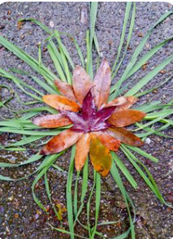 | STEM  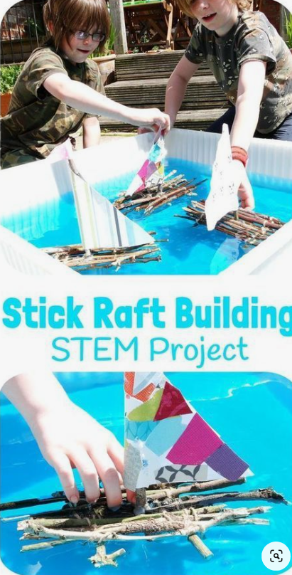  STICK RAFT BUILDING STEM CHALLENGE - Can you build a raft that really floats? How much weight can it carry?

