Maths  Mon-Fri  Should be done in order | Daily counting from any number forwards and backwards. Counting in 2’s, 5’s and 10’s Practise writing numbers 1-20 in words.
 | Monday  Ordering numbers  Look through the power point.  Then complete the work sheet.  All work sheets can be found below this table on the web page. | Tuesday  Comparing numbers  Look through the power point.  Then complete the  work sheet | Wednesday  Counting to 100  Look through the power point.  Then complete the work sheet | Thursday  Partitioning numbers  Look through the power point.  Then complete the work sheet | Friday  Problem Solving  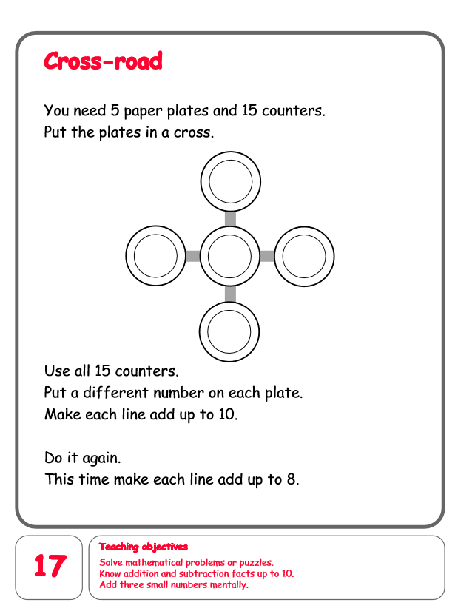
English  Mon-Fri  Choose one-a-day. | Daily Reading, Phonics ( Practise Phase 3 and Phase 5 sounds) and spelling practice ( Spellings- Common exception words and the days of the week ) Phonics game 2DO task on Purple Mash
 | Non-fiction writing  To research and write five or more facts about your favourite domestic animal. | Grammar, Punctuation and Spelling  Commands with exclamation marks.  Work through the power point then complete the work sheets below. | Comprehension  The Lion and the Mouse.  https://content.twinkl.co.uk/resource/09/a9/t-l-53192-the-lion-and-the-mouse-differentiated-reading-comprehension-activity_ver_6.pdf?__token__=exp=1590352621~acl=%2Fresource%2F09%2Fa9%2Ft-l-53192-the-lion-and-the-mouse-differentiated-reading-comprehension-activity_ver_6.pdf%2A~hmac=24f4e27d79ee56330191fb7e78506dc2f4135fffa65eca3fd531eedf81a5335d | Thursday and Friday  Rye Writers  Rye-Writers is best done on consecutive days. You can also choose when to do the 2 sessions could be on the same day, just do 2 curriculum subjects on the other day.  To follow
Curriculum  Choose one-a-day. | Science  Look at the power point about animal classification.  Activity 1  Sorting Animals.  Are they mammals, reptiles, amphibians, fish, birds and insects.  Worksheet Below.  Activity 2  Minibeast Hunt  https://content.twinkl.co.uk/resource/0f/ff/t-t-019-eyfs-minibeast-hunt-checklist-_ver_2.pdf?__token__=exp=1590426309~acl=%2Fresource%2F0f%2Fff%2Ft-t-019-eyfs-minibeast-hunt-checklist-_ver_2.pdf%2A~hmac=382f2d075115e11713ab851146f1248125c60a62f1ff97cfba44a6e16314d605 | Geography  To design your own zoo park.  Activity: Children to make a simple map of their zoo park showing which animals they would keep and the types of enclosures they would need. Design a simple key to identify these features. | ICT  Purple Mash 2Do Task – Mammals and Reptiles. Sort the organisms into the correct groups.  PSHE- Road Safety. Create an information leaflet instructing people on road safety.  Purple Mash 2Do Task | Art  To draw, paint or collage a picture of your favourite domestic animal.  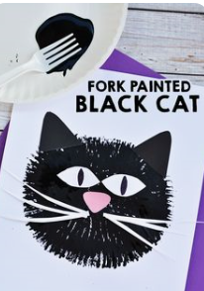 | STEM  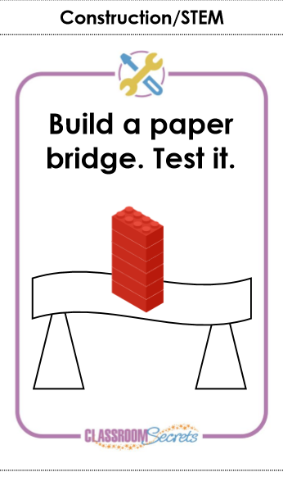  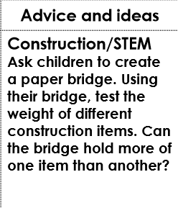  and /or  