Maths  Mon-Fri  Should be done in order | Daily counting from any number forwards and backwards. Counting in 2’s, 5’s and 10’s Practise writing numbers 1-20 in words.
 | Monday  Money word problems.  Two activity sheets to complete.  All work sheets can be found below this table on the web page. | Tuesday  10 more and 10 less  Two activity sheets to complete. | Wednesday  What happens when?  Two activity sheets to complete. | Thursday  Multiplication  Work through the powerpoint then complete the activity worksheet. | Friday  Problem Solving  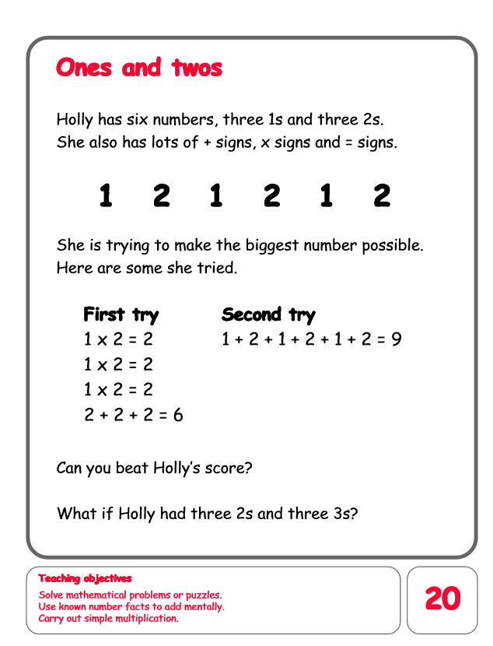
English  Mon-Fri  Choose one-a-day. | Daily Reading, Phonics ( Practise Phase 3 and Phase 5 sounds) and spelling practice ( Spellings- Common exception words and the days of the week ) Phonics game 2DO task on Purple Mash
 | Non-fiction writing  To research and write five or more facts about your favourite wild animal. | Grammar, Punctuation and Spelling  Ordering given sentences.  Read through the powerpoint.  Then complete worksheets. | Comprehension  Rainforest Comprehension  https://content.twinkl.co.uk/resource/c5/e8/t-l-9586-ks1-rainforests-differentiated-reading-comprehension-activity-_ver_1.pdf?__token__=exp=1591306675~acl=%2Fresource%2Fc5%2Fe8%2Ft-l-9586-ks1-rainforests-differentiated-reading-comprehension-activity-_ver_1.pdf%2A~hmac=957a05c5498a59b6f45477306f92dbc54cb97101ccfa42efd74307714a144e7a | Thursday and Friday  Rye Writers  Rye-Writers is best done on consecutive days. You can also choose when to do the 2 sessions could be on the same day, just do 2 curriculum subjects on the other day.  This week we would like you to read through the story powerpoint of Little Red Riding Hood. Then create a comic strip to retell the story.
Curriculum  Choose one-a-day. | Science  Please read through the powerpoint.  Activity 1: Children to sort animals according to whether they are carnivore, herbivore or omnivore on a Venn diagram https://content.twinkl.co.uk/resource/1f/fa/t-sc-054-omnivore-carnivore-or-herbivore-venn-diagram-sorting-activity-sheet-_ver_2.pdf?__token__=exp=1591307152~acl=%2Fresource%2F1f%2Ffa%2Ft-sc-054-omnivore-carnivore-or-herbivore-venn-diagram-sorting-activity-sheet-_ver_2.pdf%2A~hmac=f1051e7f6f0766e5f7ea34fd14781e545fab11b5836a1dac808ba2f774afb3c1  Activity 2. Around the house scavenger hunt.  https://content.twinkl.co.uk/resource/d2/2f/t-sc-2549922-around-the-house-scavenger-hunt_ver_3.pdf?__token__=exp=1591307275~acl=%2Fresource%2Fd2%2F2f%2Ft-sc-2549922-around-the-house-scavenger-hunt_ver_3.pdf%2A~hmac=351443e6ca9da2eb6d090c425aa28dd3044b64c5a7aa6d214c05d089326ee760 | PSHE  Sun Safety  Read through the powerpoint.  Activity: Design a sun safety poster.  https://content.twinkl.co.uk/resource/37/52/t-t-2546790-sun-safety-poster-design-activity-sheet.pdf?__token__=exp=1591366561~acl=%2Fresource%2F37%2F52%2Ft-t-2546790-sun-safety-poster-design-activity-sheet.pdf%2A~hmac=feb0569fce9b1df361ec935c610307c0da2d0f547a67f0b99dddad86a2ebdfe2 | ICT  Purple Mash 2Do Task – Choose a minibeast and write a caption to describe it.  Purple Mash 2Do Task  Music  Drag and drop sounds into the grid: explore harmony and build up musical scores. | Art  Create your own lion picture. Draw, colour, paint or collage a picture of a lion.  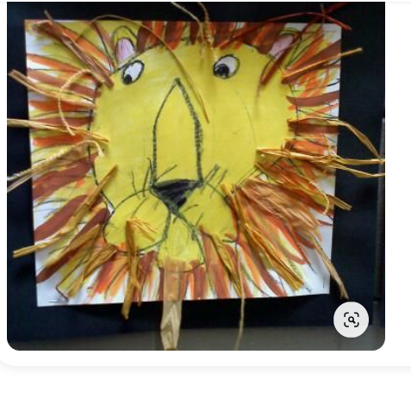 | STEM  Make a bird feeder.  