Maths  Mon-Fri  Should be done in order | Daily counting from any number forwards and backwards. Counting in 2’s, 5’s and 10’s Practise writing numbers 1-20 in words.
 | Monday  Measuring in seconds, minutes and hours.  Activity: To explore the difference between seconds, minutes and hours.  All work sheets can be found below this table on the web page. | Tuesday  Comparing time.  Activity: Comparing time using the language faster, slower, earlier and later to describe and compare how long things take to happen. | Wednesday  Activity: Name and order the months of the year and pick out special dates within the year, such as their birthday. | Thursday  Measuring time in seconds.  Activity: Measuring how long it takes to complete an activity. | Friday  Problem Solving  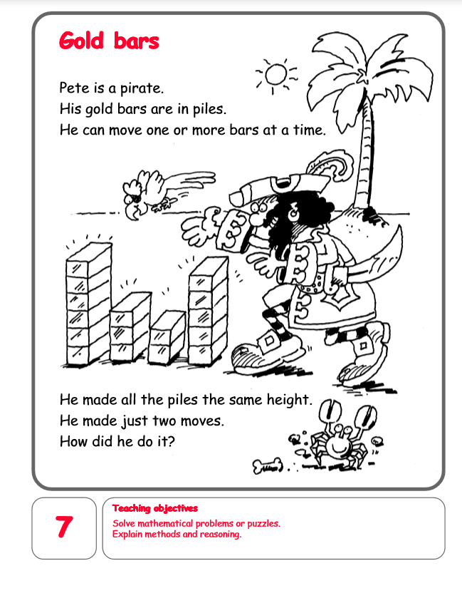  Or Most Popular sports investigation.  https://content.twinkl.co.uk/resource/7b/eb/au-n-443-most-popular-sport-data-investigation-activity-sheet-english-australian_ver_1.pdf?__token__=exp=1592400982~acl=%2Fresource%2F7b%2Feb%2Fau-n-443-most-popular-sport-data-investigation-activity-sheet-english-australian_ver_1.pdf%2A~hmac=cc5faa4b9b0905eab5c6760ea54ca4e5a3741b366985a59af4cfb192aed183c4
English  Mon-Fri  Choose one-a-day. | Daily Reading, Phonics ( Practise Phase 3 and Phase 5 sounds) and spelling practice ( Spellings- Common exception words and the days of the week ) Phonics game 2DO task on Purple Mash
 | Tiger who came to tea.  https://www.youtube.com/watch?v=z9IPZR16fdY  Activity: To write a thank you letter from the tiger to Lucy and her mum for a lovely tea. | Favourite sport  Write about your favourite sport and why you enjoy doing or watching this sport. | Comprehension  Tour De Yorkshire.  Please read through and answer the questions.  https://content.twinkl.co.uk/resource/a8/5d/t-t-2547154-ks1-tour-de-yorkshire-differentiated-comprehension-activity-sheets-_ver_5.pdf?__token__=exp=1592399769~acl=%2Fresource%2Fa8%2F5d%2Ft-t-2547154-ks1-tour-de-yorkshire-differentiated-comprehension-activity-sheets-_ver_5.pdf%2A~hmac=f3f768b6331a34374b1df0c9210761e91eb0d31a9868a41e0cb30e871b45eb3c | Thursday and Friday  Rye Writers  Rye-Writers is best done on consecutive days. You can also choose when to do the 2 sessions could be on the same day, just do 2 curriculum subjects on the other day.
Curriculum  Choose one-a-day. | Science  Mammals and Birds.  Read through the animal classification powerpoint.  Activity 1: To write three facts about mammals and three facts about birds.  Activity 2: Scavenger hunt.  https://content.twinkl.co.uk/resource/24/30/T-N-4120-Weights-and-Measures-Scavenger-Hunt-KS1.pdf?__token__=exp=1591534650~acl=%2Fresource%2F24%2F30%2FT-N-4120-Weights-and-Measures-Scavenger-Hunt-KS1.pdf%2A~hmac=e93bc9f4ec198291a59d388e017b3f00bf9424672ffd41e7b22b0a0785872068 | PSHE  Staying safe around water.  Read through the water safety powerpoint.  Activity: Design a water safety poster. | ICT  Purple Mash 2Do Task – Our senses at the seaside.  What can you taste, touch, see, hear and smell at the seaside.  Coding- Haunted Scene.  Art  Purple Mash 2Do Task- Can you draw a rock pool? | Art  Activity: To draw, paint, collage a picture of a tiger. | STEM  Grow a rainbow.  Colour a rainbow on both ends of a sheet of kitchen towel.  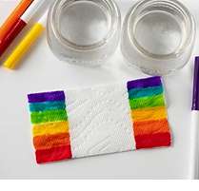  Place each end into a glass of water and watch your rainbow appear.

