Maths  Mon-Fri  Should be done in order | Daily counting from any number forwards and backwards. Counting in 2’s, 5’s and 10’s Practise writing numbers 1-20 in words.
 | Monday  Position and direction.  Turns, clockwise and anticlockwise.  Read through the powerpoint.  Activity: following directions using turns, clockwise and anticlockwise. | Tuesday  Addition and subtraction word problems.  Please read through the word problems with your child.  Activity: To solve the word problems. | Wednesday  Reasoning Problems.  Please read through the Reasoning problems with your child.  Activity: To solve the reasoning problems. | Thursday  Number bonds.  Activity: Rainbow bonds. | Friday  Problem Solving  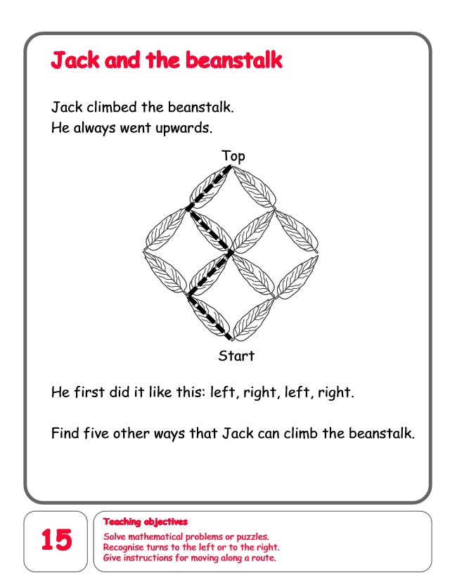
English  Mon-Fri  Choose one-a-day. | Daily Reading, Phonics ( Practise Phase 3 and Phase 5 sounds) and spelling practice ( Spellings- Common exception words and the days of the week ) Phonics game 2DO task on Purple Mash
 | Poetry  Commotion in the Ocean  https://www.youtube.com/watch?v=9pRhgZ8Jffs  Please write a poem about your favourite sea creature. | Grammar, Punctuation and Spelling  Activity 1: I can add ‘ed’ to make a new word.  Activity2: Adding the prefix un word search.  work sheet. | Comprehension  Formidable Sid  Please read through and answer the questions.  https://content.twinkl.co.uk/resource/e4/a0/t-e-1000-year-1-formidable-sid-differentiated-reading-comprehension-activity_ver_4.pdf?__token__=exp=1591724731~acl=%2Fresource%2Fe4%2Fa0%2Ft-e-1000-year-1-formidable-sid-differentiated-reading-comprehension-activity_ver_4.pdf%2A~hmac=bb8d6cc0fa6e6f8a9eeaef2a3a26e50c49eca24ae80eaa771e8b76e0058b0703 | Thursday and Friday  Rye Writers  Rye-Writers is best done on consecutive days. You can also choose when to do the 2 sessions could be on the same day, just do 2 curriculum subjects on the other day.  This week we would like you to read through the story powerpoint The Magic Porridge Pot. Then create a comic strip to retell the story.
Curriculum  Choose one-a-day. | Science  Read through the animal bodies powerpoint .  Activity 1: Bizarre Beasts.  Activity 2: 2D and 3D shape scavenger hunt | History  Read through the powerpoint about Rosa Parks.  Activity: Write some facts about Rosa Parks. | ICT  Purple Mash 2Do Task – Can you invent your own minibeast.  Purple Mash 2Do Task  What can you see in the sea?  Draw your own sea creature.  Purple Mash 2Do Task  Coding Help the superheroes use their powers. | Art  Rainbow Fish  Please draw, colour, paint or collage a picture of Rainbow Fish.  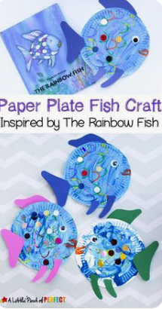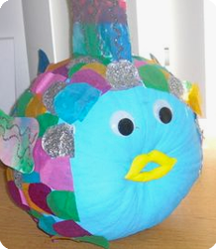 | STEM  Shadow Drawing  