17.5.21
L.I: To describe what plants need to grow and stay healthy.
Steps to success
*I can explain that plants need water, light and a suitable temperature to grow well.
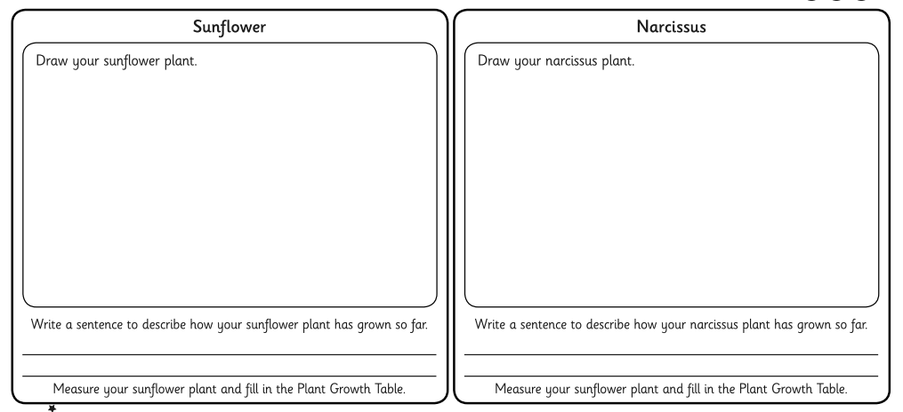

17.5.21
L.I: To describe what plants need to grow and stay healthy.
Steps to success
*I can explain that plants need water, light and a suitable temperature to grow well.

