Monday 22nd February
LI: To write a non-fiction text.
Cold Task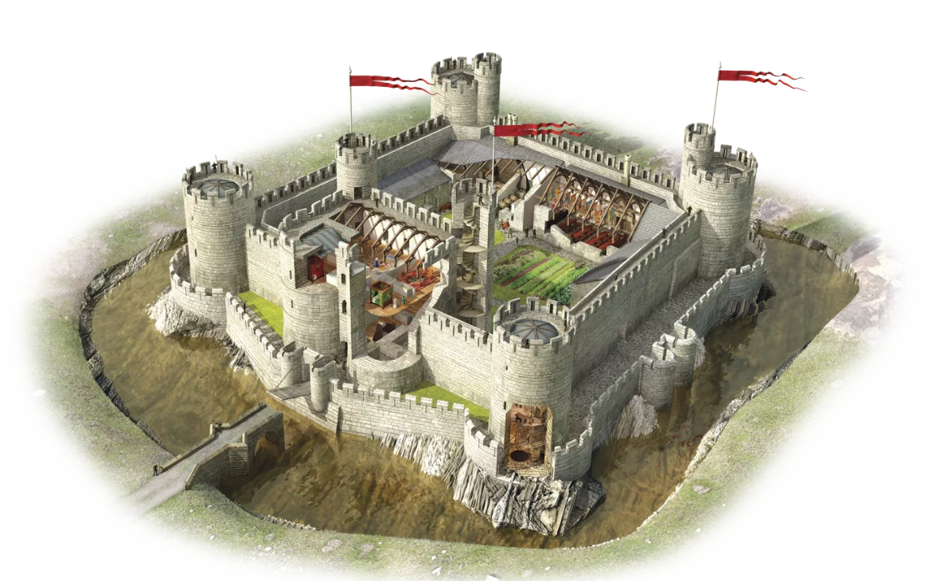
Note to parents: There will be a brief outline of the task in the assembly on Monday and on the audio Powerpoint.
The purpose of a cold task is to give a starting point for teaching and learning. The most important aspect is that children have a go. All writing should be encouraged!
Whilst the children may not know much about castles, they can describe what they see, what they think parts of the castle are for, what they like or not. Although this is factual writing, some may write a story. This is fine; we will take the time to learn about the differences between fiction and non-fiction writing.
Over the next two weeks, we will be learning about writing information texts and about castles themselves, so any issues that arise will be addressed.

