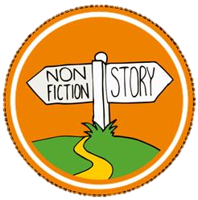
Tuesday 23rd February
LI: To know the features of a non-fiction text
- I can recognise the main heading, introduction, subheading and topic of an information text (non-chronological report)
- I talk about what I have listened to. (Band 1/2 - Comprehension)
- I can explain my understanding of texts which have been read to me. (Band 1/2 - Comprehension)
- I can enjoy and understand books by listening to and talking about non-fiction books that I can’t read myself (Band 2 – Comprehension)
Can you find any of these features on other non-fiction texts? Perhaps you have animal books at home?
Note to parents:
Non-fiction is factual writing.
In the first two weeks of term, we will be learning about writing information texts.
These are also known as non-chronological reports as they writing doesn’t necessarily follow a sequence of events in the same way a story does.

The purpose of today’s learning is to recognise the layout and features of an information text and understand that these parts can be seen in many kinds of non-chronologic reports. This is explained further in the PowerPoint audio that accompanies the lesson.

The texts have been chosen as they relate to our topic and demonstrate the key features. They can be read aloud, even summarised to match your child’s understanding. They don’t all need to be read. You may also have some non-fiction books at home that can be explored and enjoyed for the features too.

Almost all the learning will be done through talking and exploring texts. For this reason, you may not feel that you need to print out all, if any, of today’s sheets.

We are going to use these shapes to help us to learn about information texts.
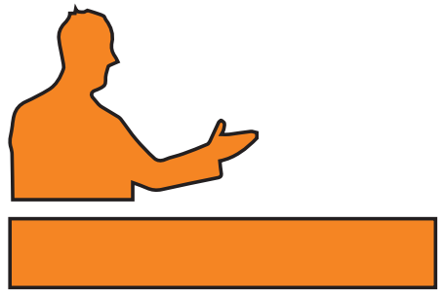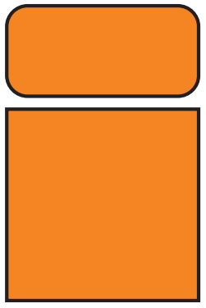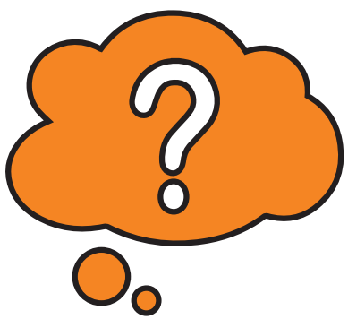
Topic
Key information that you want to know.
Thinking Question
Sometimes there is a question to make you think.
It may begin with,
“Did you know that...?” or,
“Can you think of...”
Sub-Heading
Main Heading
This is the main title of the page
Introduction
This tells what the page is about.

Can you find these features in the information texts?

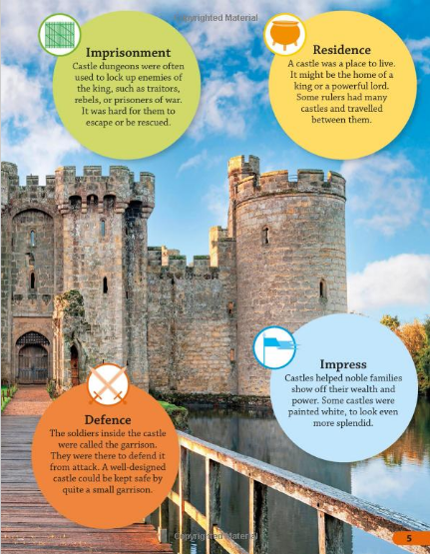
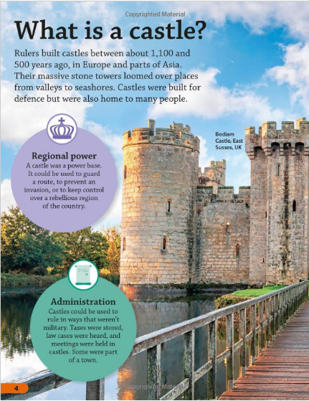
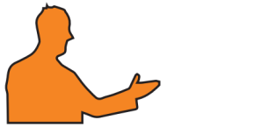 |  |  | 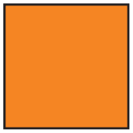
Main Heading | Introduction | Sub-Heading | Topic | Thinking Question

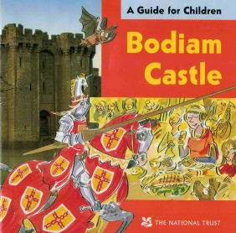
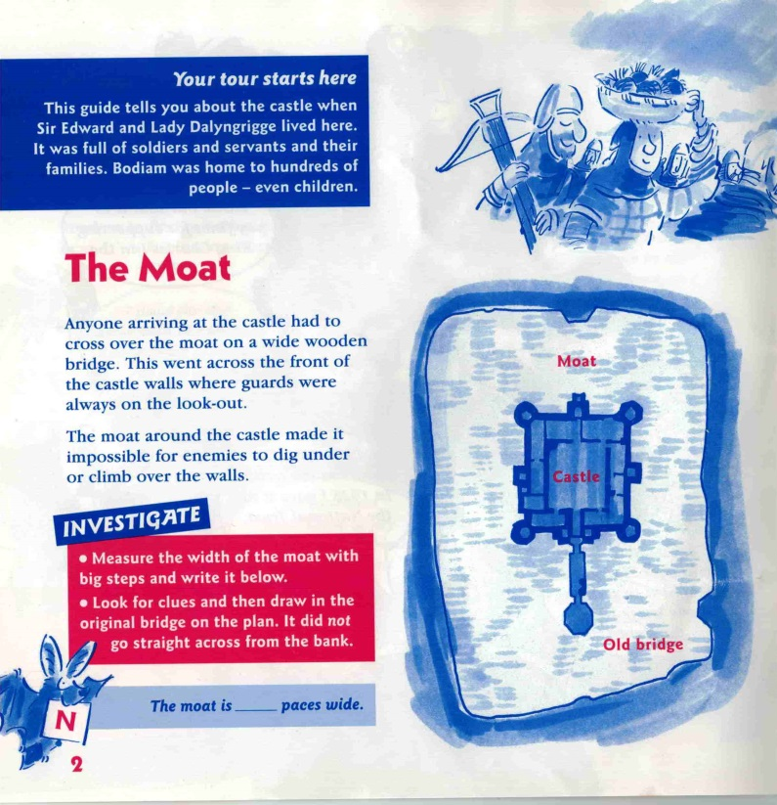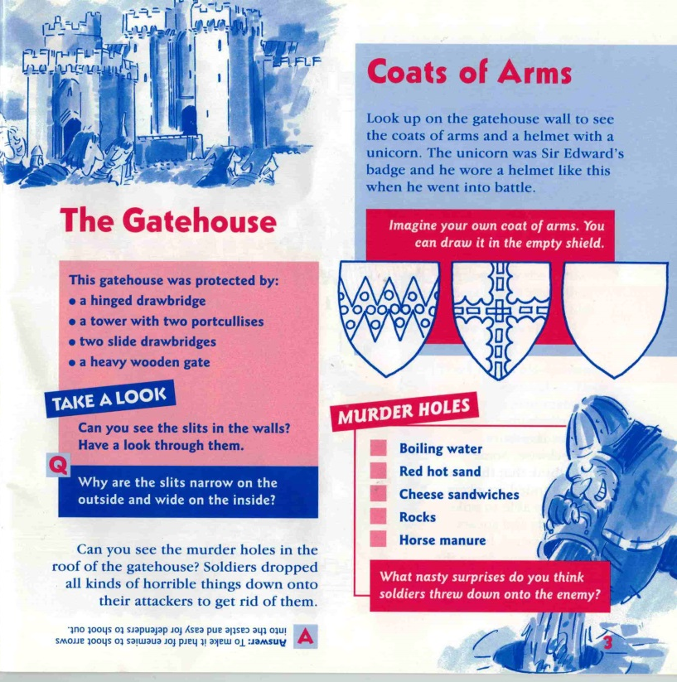

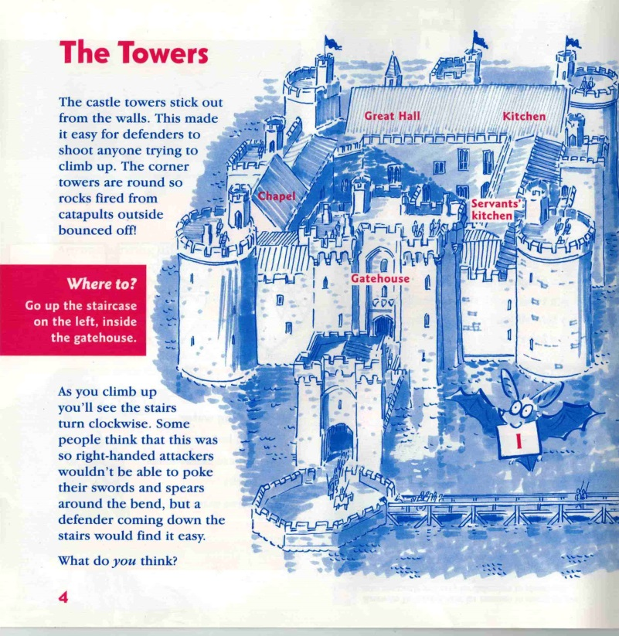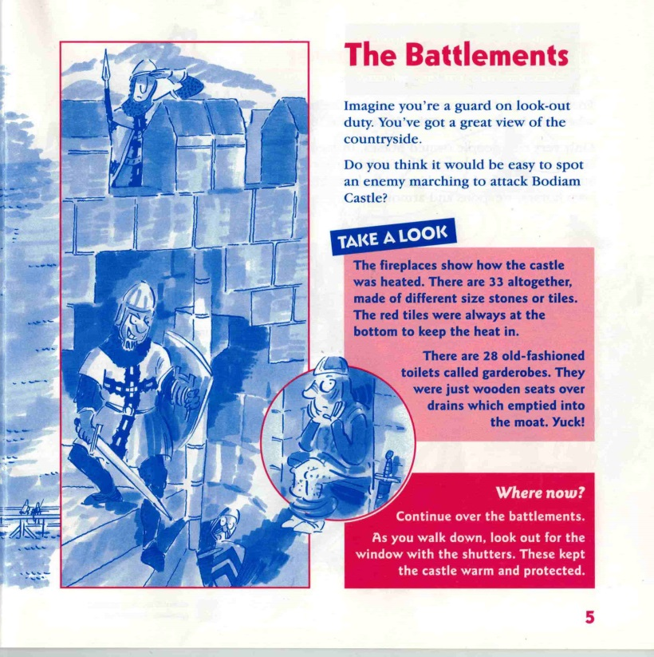
Main Heading | Introduction | Sub-Heading | Topic | Thinking Question

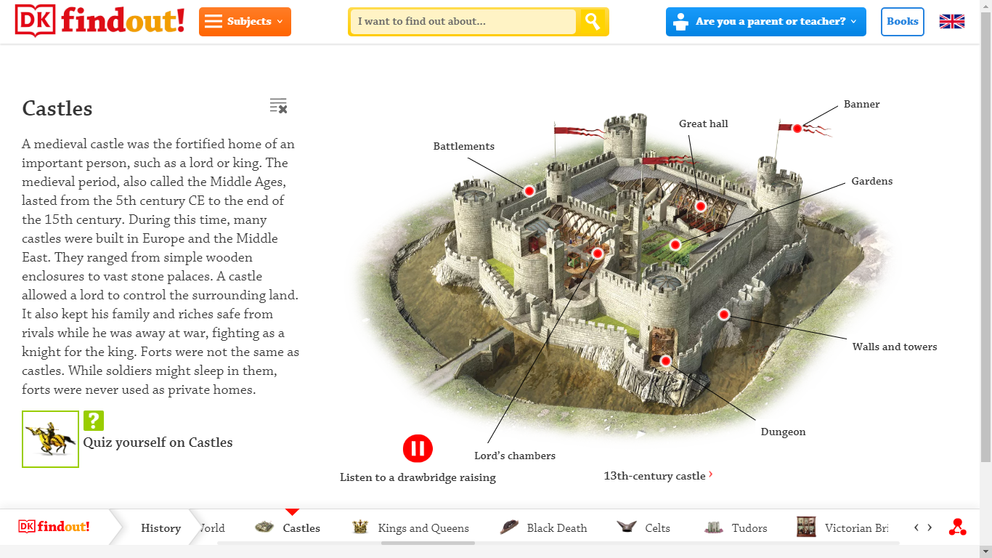
This is from an interactive webpage. It’s worth a look! When you click on the red dot, the topic writing appears.
https://www.dkfindout.com/uk/history/castles/
Main Heading | Introduction | Sub-Heading | Topic | Thinking Question

