__________________________________ Sentence Stacking//
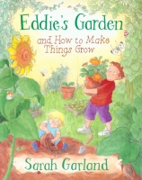
LI: To know the features of instructions.
(Band 1) Steps to success:
- I write a title.
- I can use questions marks.
- I can write a list.
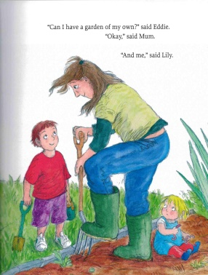
Learning Chunk 1: Title.
Text layout | Model:  How to grow plants.

Learning Chunk 2: Question
Basics | Model:  Do you want to grow your own garden? Let me tell you how.

Text layout | Model:  You will need:

