Wednesday 21st April Sentence Stacking/
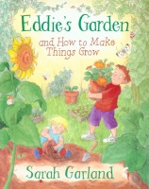
LI: To know the features of instructions.
(PKS) Steps to success:
- I use the sounds I know for writing.
- I talk about what I want to write.
- I am beginning to write sentences.
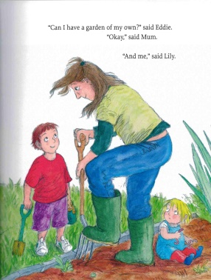
Learning Chunk 1: Title.
Text layout | Model:  How to grow plants.
 | How to

Learning Chunk 2: Question
Basics | Model:  Do you want to grow your own garden?

Text layout | Model:  You will need:
 | You will need:

