Choose a country that you would like to find out more about. Where is it on a world map? What fruit and vegetables grow there? What food is it famous for?  Why not try cooking a snack or meal inspired by the country. | Make a flower or plant information scrap book. How many do you know already? How many new things can you find out about? Can you name 10 different ones? | Go on a nature walk. Take photos and or sketches of what you find growing.
Visit a woodland area, park, arboretum or public garden. Has the area been organised or is it wild? What is growing? How is it looked after? How does it make you feel? | Change the colour of a flower’s petals!  Information attached and on webpage. | Measure a plant that you have growing and measure yourself.  What do you both need to stay healthy?  What change do you notice over this 6 week term?
In class we have looked at Vincent Van Gogh’s Sunflower paintings. Are these the only flower based paintings that he made? What other artists can you find out about who used flowers, plants, trees or fruits and vegetables as their stimulus? | Make some plant or flower inspired art work. You could make a pattern or collage with seeds or take crayon rubbings of different tree barks. Or why not try doing some printing with petals, cut up fruits and vegetables and paint. | What is Fairtrade food?  Do you have any in your home?  Can you make a poster or information leaflet to explain why Fairtrade is important?
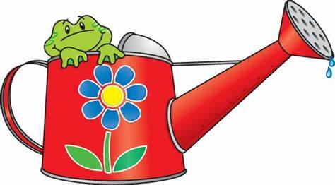
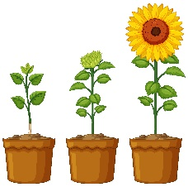
Please choose one challenge to complete each week and put the date in the box when you have done it.
Remember you will also have a reading task to complete on Reading Eggs and a maths task to complete on Maths Seeds. You should also be practising your spellings and reading daily.
We have left these tasks fairly open ended so that you can be creative! Make things look nice through adding colour. Use your imagination and take pride in your work. You can take photos, use a computer or record through writing and drawing. We don’t expect you to do all of these tasks but if you want to that is fine. Please bring your homework book in by Thursday each week and date the work you have completed. Happy learning and have fun!

