6th October 2017
AFTER SCHOOL CLUBS TERM 2

Dear Parents and Carers,

We are changing the way you can book your child onto an after school club. In term 2 we are going to be running all the clubs listed on the timetable on the reverse of this letter.

Clubs will run for 6 weeks from the week commencing 30th October, if your child would like to join an after school club then please complete the slip at the base of this letter and return to the school office with any payment by Friday 13th October.
As you can appreciate after school clubs are very popular and can become oversubscribed, we will try our best to place your child on their choice of clubs, however if this is not possible then we will place them on a waiting list and hold your refund in the office for you to collect.
If your child is unable to attend a club for any reason then it is your responsibility to notify the school office. Please note that poor behaviour and attendance in school or at an after school club may lead to your child’s place on club being removed and offered to another child.

We will contact you by email before Friday 20th October if your child has secured a place on their chosen club, please ensure we have an up to date and valid email address for you. If you do not receive an email your child has not gained a place and you will need to collect at the normal time.

Please ensure your child has the appropriate clothes and footwear for sports clubs as well as a named water bottle. Some sports clubs can take place outside so we recommend you child is suitably equipped with warm, waterproof clothing, Children can wear their school PE kit but school shoes will not be permitted.

Yours sincerely
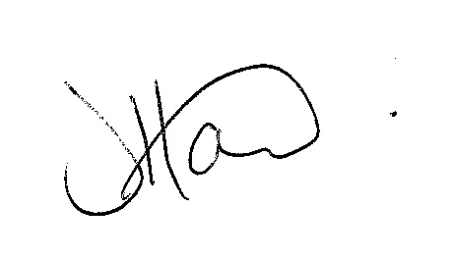
Ms J Howard
Headteacher

*************************************************************************************************************************

Child’s Name ………………………………………………………. Class ………………………………………

I would like my child to take part in the following clubs….

1…………………………………………………………………

2…………………………………………………………………

3…………………………………………………………………

4………………………………………………………………...
I have paid via Schools Cash Office
I enclose cash/cheque for £……….
My child is entitled to Pupil Premium and I would like to apply for funding

My email address is……………………………………………

Signed ……………………………………. Print Name…………………………………………

