Year 6 Residential Trip - 2018

Dear Parents / Carers

As you may know, every year we take a group of Year 6 children on a residential trip in June.

A provisional booking has been made to take a group of pupils to Hindleap Warren Outdoor Education Centre, from Monday 18th June – Friday 22nd June 2018.

Hindleap is a purpose built Outdoor Education Centre in a beautiful position on the northern edge of Ashdown Forest. They have 300 acres of woodland grounds which means the children stay on site for most of the course. Each day will be filled with activities such as kayaking, mountain biking, archery, abseiling, caving, obstacle courses and others. For more information, please see the following website: www. londonyouth.org/residential-centres/hindleap-warren.

The cost of the trip will be approximately £340 per pupil (final price will be confirmed in October); included in this price is:

• Return travel by coach from school
• Full board accommodation
• A full programme of on-site activities
• Evening entertainment and activities
• Full comprehensive insurance

The only additional cost will be spending money for the on-site tuck shop. The trip will be led by members of teaching staff who will be responsible for supervising the children when not on activities. All of the activities will be delivered and led by the Hindleap Warren instructional staff who are all highly experienced, well qualified professionals. The centre is a first class operator with a solid reputation for organising school holidays with, over 30 years’ experience in the school travel business.

If you would like your child to take part in this exciting trip, please return the attached reply slip with an initial deposit of £65 to be paid by Monday 2nd October. The balance can be paid in instalments, the final balance must be paid by Friday 2nd March 2018. Details of the amount of each instalment and the date by which it will be due will be released once we have final numbers and deposits. Unfortunately, we cannot guarantee any refunds.

To ensure your child’s place on the trip, please ensure your forms and deposit are returned on time. Payments can be made online via Schools Cash Office, alternatively cash or cheques (made payable to Rye Community Primary School, with your cheque guarantee number on the back) can be sent to the school office in a named envelope. Payment cards will be distributed in October with remaining payment information.

If you have any queries, or any short term problems with the payment of the deposit please do not hesitate to contact us.
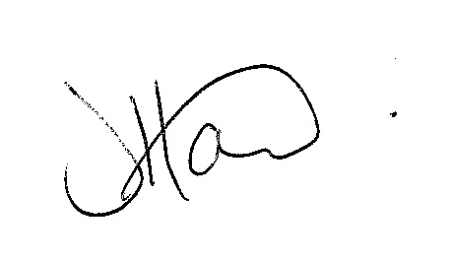
Yours sincerely

Ms J Howard
Headteacher

Residential Trip 2018

To confirm a place on the residential trip please complete and return this slip with your deposit of £65.00 by Friday 2nd October 2017.

Child’s Name…………………………………………………………

Y6 Class …………………………………………………………………

I enclose my payment of £65.00 as a deposit for the Residential Trip to Hindleap Warren in June 2018.

I have paid via Schools Cash Office online

I enclose cash/cheque

Signed …………………………………………………………….. Parent /Carer

Date ………………………………………………………………..

