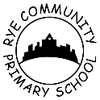 Violin Lessons 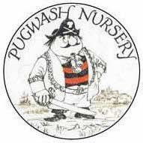

Lynne Ratcliffe is a violin teacher and has taught many children at Rye Primary to play the violin.
Lynne is currently recruiting children for violin lessons and wanted to share with parents the benefits of playing a musical instrument. If you are interested and would like to find out more information then please come along and see Lynne on Wednesday 13th February, she will be in the Children’s Centre from 8.30am.

