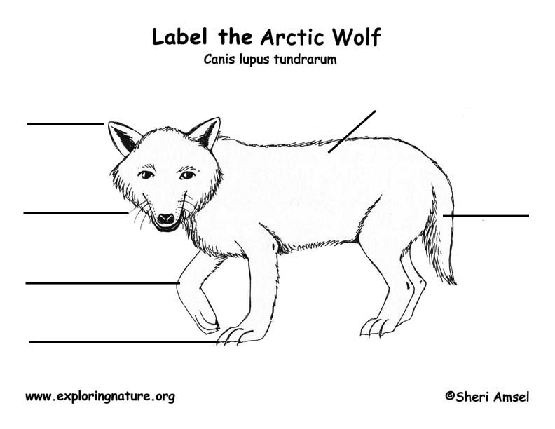

pointy ears thick fur, paws with claws, bushy tail, whiskers