[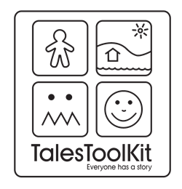](http://www.google.co.uk/url?sa=i&rct=j&q=&esrc=s&source=images&cd=&cad=rja&uact=8&ved=2ahUKEwisrrDr_NvgAhUm3OAKHXrzC-4QjRx6BAgBEAU&url=http://talestoolkit.com/&psig=AOvVaw25Xv_snNuOwqFHupWTmS1m&ust=1551358996561862)

LI: to describe key features of a story (character, setting, problem, solution)