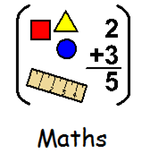
21.03.2022 Band 1
LI: To compare length
Steps to Success:
- I solve problems with length by telling which object is longer or shorter.
- I use language to compare lengths:
I P T TA

1.
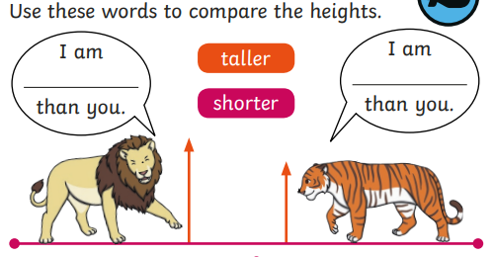
2.
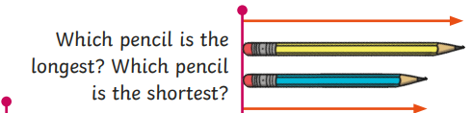
.
3.

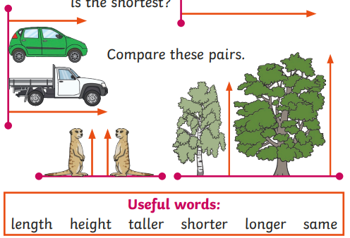

4.  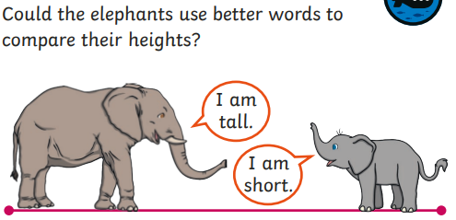 | 4.

5.  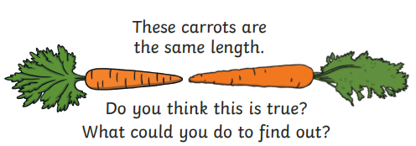 | 5.

6.  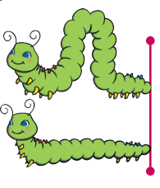  Are these caterpillars the same length?  How do you know? | 6.  Are these caterpillars the same length?  How do you know?

