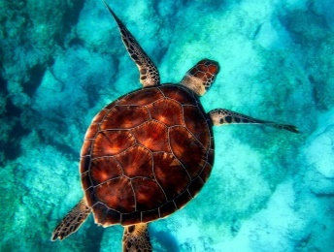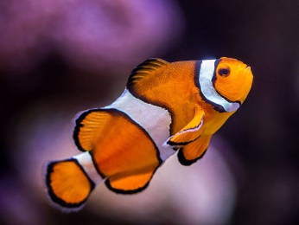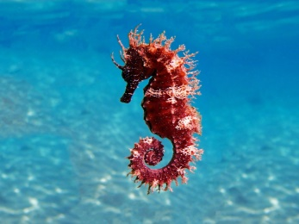

Welcome back to Term 6!

We hope that you and your families had a restful and enjoyable May half term. We are very sad to be coming to the end of the school year, but are so proud of how much progress the children have made. Let’s make this the best term yet, as for some of our children, this will be their last term in KS1!

Our topic this term is ‘On Safari’.

English
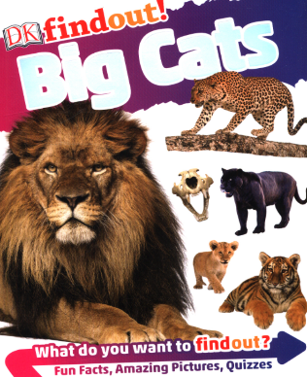
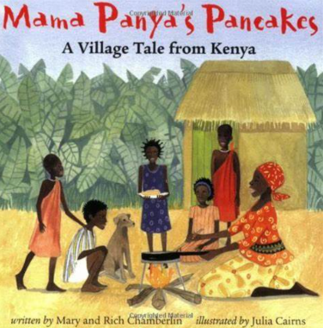
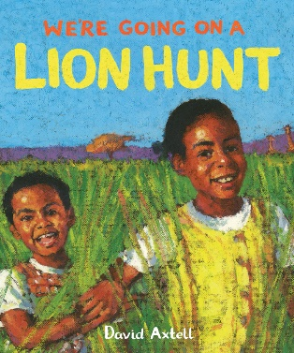
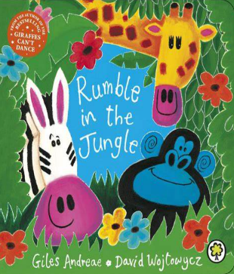

This term, our key texts are “Big Cats” by DK (Non-fiction), “Mama Panya’s Pancakes - A Village Tale from Kenya” by Mary and Rich Chamberlin, “We’re going on a Lion Hunt” by David Axtell and “Rumble in the Jungle” by Giles Andreae. Using our texts as a starting point, we will be writing our own Non-Fiction texts and poems.

Teaching Phonics - Little Wandle Letters and Sounds
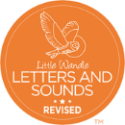
We will be continuing with the Little Wandle Letters and Sounds phonics programme. Although your child will be taught to read in school, you can have a huge impact on their reading journey by continuing their practice at home.
Your child will have three types of reading book:
- An e-reading practice book. This will be at the correct phonic stage for your child. They should be able to read this fluently and independently.
Please let us know if you need another copy of the link for the e-reading book.
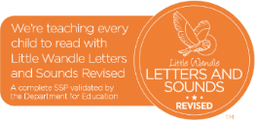
- A library book. Your child may not be able to read this on their own. This book is for you both to read and enjoy together.
- A Reading Passport Challenge book.

How You Can Help
There is a school expectation that all KS1 children should read daily at home. Talk to them about what they are reading, ask them questions about the story, characters and plot. Perhaps they can they predict what will happen next?
Look at information texts with your child and look at the glossary and contents page to find out where you could locate more information.
Our focus this term is on punctuation and how we can use it in our writing.
We are also beginning to use joined handwriting. Please encourage your child to form their letters correctly when they are writing at home. Further information about this will be sent home soon, but if you are unsure about this, please come and ask us.

Maths
In Maths this term, we will be continuing to practise telling the time, before moving on to measuring weight, mass and capacity.

How You Can Help

Support your child’s learning by encouraging your child to tell the time throughout the day.

Practise feeling how heavy and light objects are and putting them in order. Fill containers to different levels and compare empty, almost empty, half full, three quarters full, full.

Practise reading scales on kitchen scales measuring jugs – cooking is the perfect opportunity for this!

Learn your number bonds to 10 and 20.
Continue to help your child learn their times-tables by learning the multiples of 2, 5 and 10 (year 1) and 2, 5, 10 and 3 (year 2).

PE and Forest School
Clownfish – Tuesday Athletics (Outdoors) and Wednesday Swimming.
Seahorses – Tuesday Athletics (Outdoors) and Wednesday Swimming.
Sea Turtles, Year 1 – Tuesday Athletics and Wednesday Swimming.
Sea Turtles, Year 2 - Tuesday Forest School and Wednesday Swimming.
All PE kit and uniform should be named so they can be returned easily if they are found. Details of school uniform can be found on the school website:
https://ryeprimary.co.uk/school/Uniform
Forest School
All classes will take part in Forest School over the course of the year. Children will need to bring in a long-sleeved t.shirt and trousers, water-proofs and wellington boots. As always, these items should be named to avoid getting them lost.

Home Learning
In Key Stage 1, homework is set weekly. Reading Eggs and Maths Seeds tasks are set after school on a Friday and should be completed by the following Friday. You will have been sent the login details in your child’s reading record book, but please ask their class teacher if you need them again! Any children who have been unable to complete their online homework tasks will be able to do their homework in the computer suite on a Friday lunchtime.
Spellings are also set on Fridays. They are posted on the class webpages, as well as on Class Dojo. The children write their spellings in a test the following Friday.

Water Bottles and snacks
A hydrated brain is essential to learning! Please ensure that your child brings in a named water bottle. All key-stage 1 children are offered a healthy snack each day. They can also bring in their own healthy snack to have in snack time. It is really helpful if water bottles and fruit-tubs are named so they can be returned if they get lost.

Due to severe nut-allergies, we are a nut-free school.
Please ensure all snacks and lunch box items are nut-free, including biscuits such as cereal bars.We are extremely appreciative of your support in this.

As always, please do not hesitate to contact us if you have any questions or queries. The easiest way to do so is by leaving a message with the office, or using the message facility on ClassDojo.

Thank you for your continued support.

Mrs Leigh, Miss Brewster and Miss Birkby
Sea Turtles’, Clownfish and Seahorses’ Teachers

Further information about our classes and learning, including timetables and home learning, can be found on our class webpages.
https://www.ryeprimary.e-sussex.sch.uk/curriculum/class
