Fluency

Write down the number represented with base 10:

1.

2.

3.
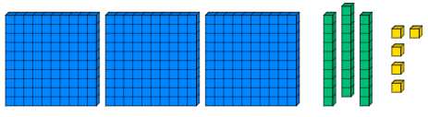
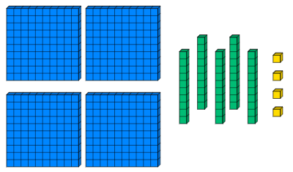
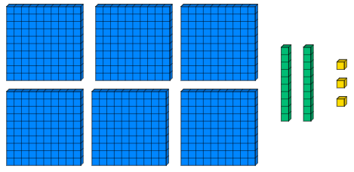

Draw place value counters to represent the following numbers:

4. 479

5. 835

Reasoning

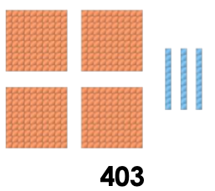
6. True or false? The image below represents the number. Explain your answer.

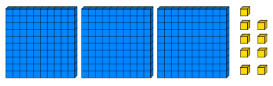
7. Sally says, “I have made the number 390.” Do you agree? Explain your answer.

