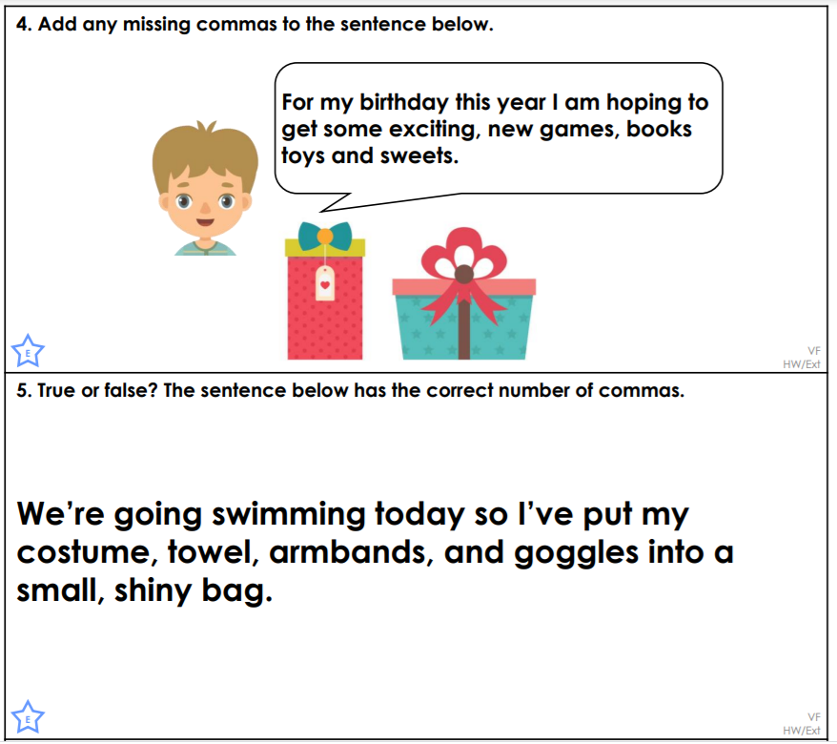
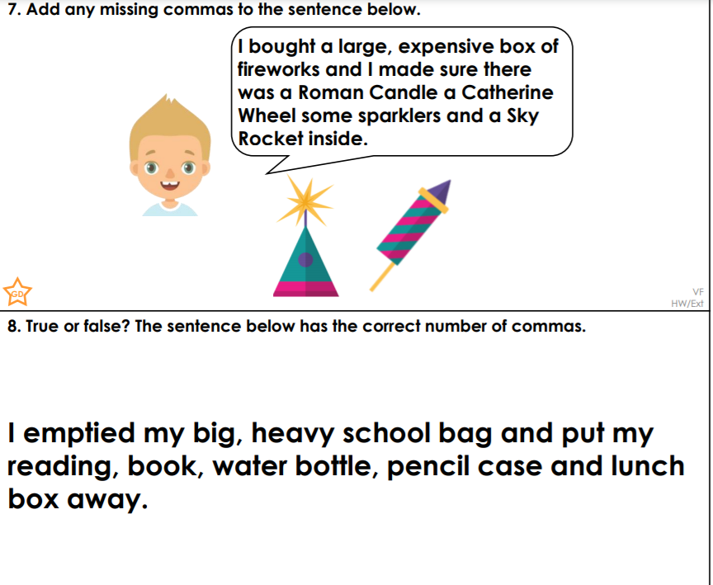
Year 4: Add a fronted adverbial to the above sentences, using a comma correctly.

