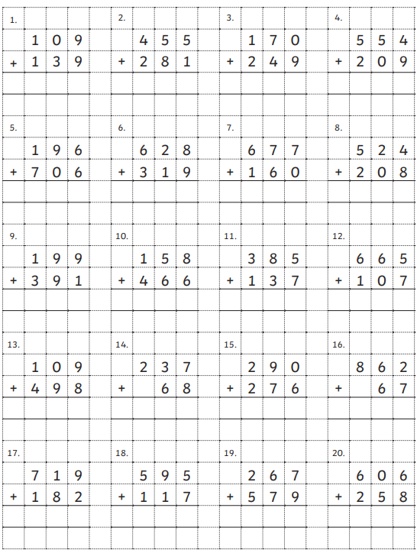
Write these straight into your book. Draw the base 10 if you need to.

