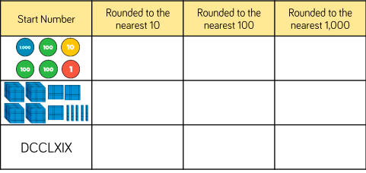
Write the tens either side of the given number and mark it approximately on the number line. Then circle the 10 to which the given number is closer. (Remember, 5 goes up.)
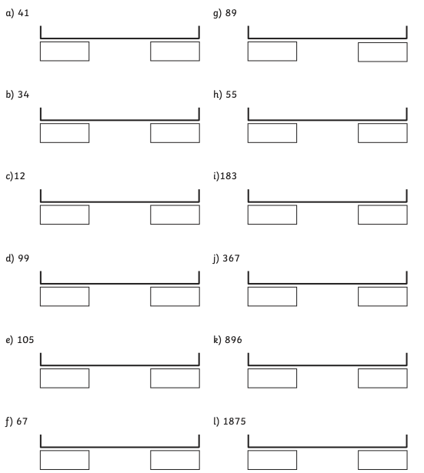
Round the following to the nearest 100:

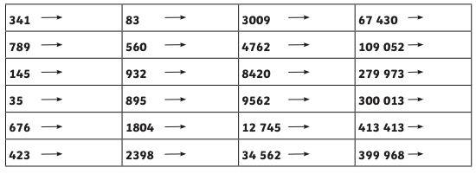

Round these numbers to the nearest 1000:

