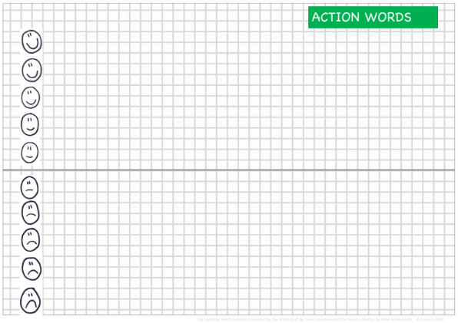

FEELING WORDS

FEELING WORDS