22.2.21
L.I: I can identify different everyday materials.

Match the materials to their uses.
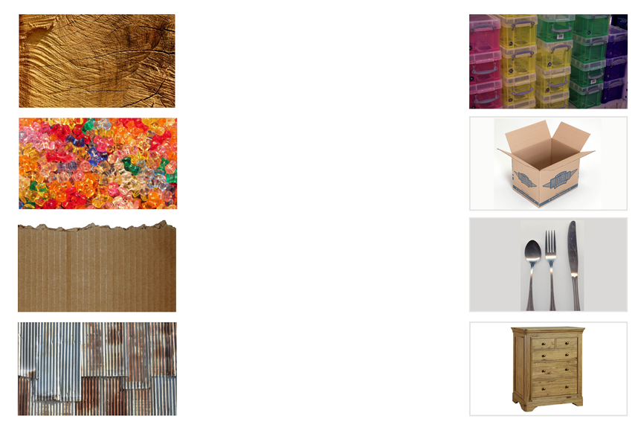
Can you think of your own uses for the material below?
Can you draw the uses and match them to the correct material?

