9.3.21 History Year 1
L.I: To know who lived in a medieval castle.
Steps to success
*I know who lived in a medieval castle.
* I know which medieval were the most and least powerful.
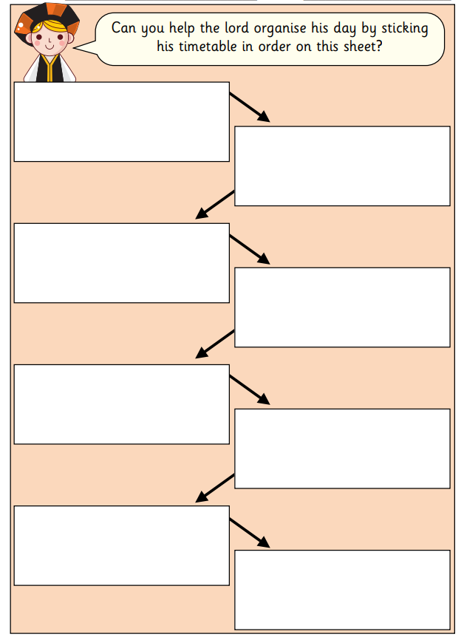

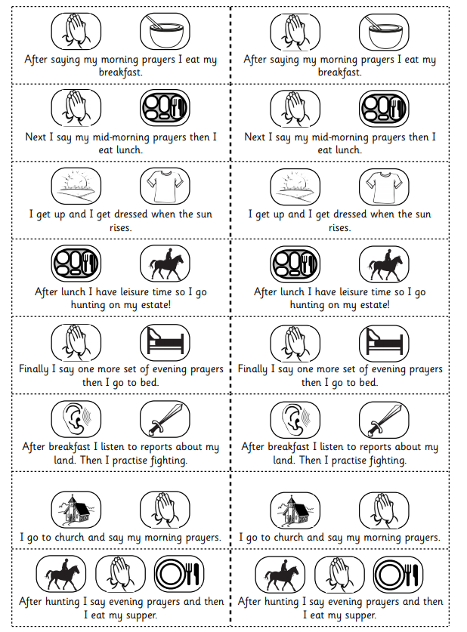

Task 2
