Rye Primary School
PSHE Policy 2018

At Rye Primary, children’s wellbeing, happiness and safety are our first priority, and PSHE is the key vehicle through which we share this with children. We regard PSHE as an important, integral component of the whole curriculum; it is central to our approach and at the core of our ethos.

Our PSHE curriculum is broad and balanced, ensuring that it:
Promotes the spiritual, moral, cultural, mental and physical development of our children and of society.
Prepares our children for the opportunities, responsibilities and experiences they already face and for adult life.
Provides information about keeping healthy and safe, emotionally and physically.
Encourages our children to understand how all actions have consequences and how they can make informed choices to help themselves, others and the environment.

Aims and Objectives
We believe that education in PSHE and citizenship enables children to become healthier, more independent and more responsible members of society. We encourage our pupils to play a positive role in contributing to the life of the school and the wider community. In so doing, we help to develop their sense of self-worth. We teach them how society is organised and governed. We ensure that the children experience the process of democracy through participation in the childrens leadership team. We teach children about their rights and about their responsibilities. They learn to appreciate what it means to be a positive member of a diverse and multi-cultural society.
Our objectives in the teaching of PSHE and citizenship are to:
• know and understand what is meant by a healthy lifestyle;
• be aware of safety issues;
• understand what makes for good relationships with others;
• have respect for other people and show sensitivity towards others;
• be thoughtful and responsible members of their community and their school;
• become active members of our democratic society; • develop self-confidence and self-esteem;
• make informed choices regarding personal and social issues; • develop good relationships with other members of the community.
• Anti-Bullying and how we should treat other with respect

The Early Years Foundation Stage

We teach PSHE and citizenship in reception classes as an integral part of our topic work. We also have daily circle times and read stories which engage the children in discussions. We will have role play and puppets also to promote PSHE within our teaching. Our links with parents also provide an insight to current interests and events in their lives so learning can be directly linked.

As the reception class is part of the Early Years Foundation we relate the PSHE and citizenship aspects of the children’s work to the objectives set out in the Early Learning Goals (ELGs) particularly the area of learning focused on a child’s personal and social development. Our teaching in PSHE and citizenship matches the aim of developing a child’s personal, emotional and social development as set out in the ELGs. We also support citizenship education in reception classes, when we teach “how to develop a child’s knowledge and understanding of the world.”

Development Matters
Personal, Social and Emotional Development:

Making Relationships; Early Learning Goal
Children play co-operatively, taking turns with others. They take account of one another’s ideas about how to organise their activity. They show sensitivity to others’ needs and feelings, and form positive relationships with adults and other children.

Self-Confidence and Self Awareness; Early Learning Goal
Children are confident to try new activities, and say why they like some activities more than others. They are confident to speak in a familiar group, will talk about their ideas, and will choose the resources they need for their chosen activities. They say when they do or don’t need help.

Managing feelings and behaviour; Early Learning Goal
Children talk about how they and others show feelings, talk about their own and others’ behaviour, and its consequences, and know that some behaviour is unacceptable. They work as part of a group or class, and understand and follow the rules. They adjust their behaviour to different situations, and take changes of routine in their stride.

Understanding the World-People and Communities; Early Learning Goal
Children talk about past and present events in their own lives and in the lives of family members. They know that other children don’t always enjoy the same things, and are sensitive to this. They know about similarities and differences between themselves and others, and among families, communities and traditions.

During Key Stages 1 and 2, PSHE education offers both explicit and implicit learning opportunities and experiences which reflect pupils’ increasing independence and physical and social awareness as they move through the primary phase. It builds on the skills that pupils started to acquire during the Early Years Foundation stage (EYFS) to develop effective relationships, assume greater personal responsibility and manage personal safety, including online. PSHE education helps pupils to cope with the changes at puberty, introduces them to a wider world and enables them to make an active contribution to their communities.

Key Stages 1 and 2

CORE THEME 1: HEALTH AND WELLBEING

This core theme focuses on:
1. What is meant by a healthy lifestyle.
2. How to maintain physical, mental and emotional health and wellbeing.
3. How to manage risks to physical and emotional health and wellbeing.
4. Ways of keeping physically and emotionally safe.
5. About managing change, including puberty, transition and loss.
6. How to make informed choices about health and wellbeing and to recognise sources of help with this.
7. How to respond in an emergency.
8. To identify different influences on health and wellbeing.

CORE THEME 2: RELATIONSHIPS

This core theme focuses on:
1. How to develop and maintain a variety of healthy relationships, within a range of social/cultural contexts.
2. How to recognise and manage emotions within a range of relationships.
3. How to recognise risky or negative relationships including all forms of bullying and abuse.
4. How to respond to risky or negative relationships and ask for help.
5. How to respect equality and diversity in relationships’.

CORE THEME 3: LIVING IN THE WIDER WORLD (ECONOMIC WELLBEING AND BEING A RESPONSIBLE CITIZEN)

This core theme focuses on:
1. About respect for self and others and the importance of responsible behaviours and actions.
2. About rights and responsibilities as members of families, other groups and ultimately as citizens.
3. About different groups and communities.
4. To respect diversity and equality and how to be a productive member of a diverse community.
5. About the importance of respecting and protecting the environment.
6. About where money comes from, keeping it safe and the importance of managing it effectively.
7. The part that money plays in people’s lives.
8. A basic understanding of enterprise.

Teaching and Learning
During timetabled PSHE time, an emphasis is placed on both written and active learning through planned discussions, circle-time, investigations, role-play activities, puppets, group-work and problem-solving.
All teachers will endeavour to provide a safe learning environment through the establishment of clear Classroom Rules which are made explicit to the children and reinforced consistently.
Visiting speakers such as the police and health workers also contribute to the taught curriculum.
Beyond timetabled PSHE lessons, pupils are supported in applying the skills they are learning, in real life situations as they arise: e.g. resolving conflicts; working as part of a group on a project and sharing their thoughts on a school matter to a wider group.
Children are encouraged to take part in a range of practical activities to promote active citizenship, e.g. charity fund-raising, the planning of special events at school; making class rules, Children Leadership meetings, and by taking on roles of responsibility for themselves, for others and for the school. PSHE Education themes are often completed cross curricular through other subjects, in particular, Science, Geography, Drama and Literacy.

British Values
The DfE have reinforced the need “to create and enforce a clear and rigorous expectation on all schools to promote the fundamental British Values of; - Democracy - The Rule of Law - Individual Liberty - Mutual Respect and tolerance of those with different faiths and beliefs.”
The government set out its definition of British values in the 2011 Prevent Strategy, and these values have been reiterated by the Prime Minister (2014).
At Rye Primary School, these values are reinforced regularly and in the following ways:
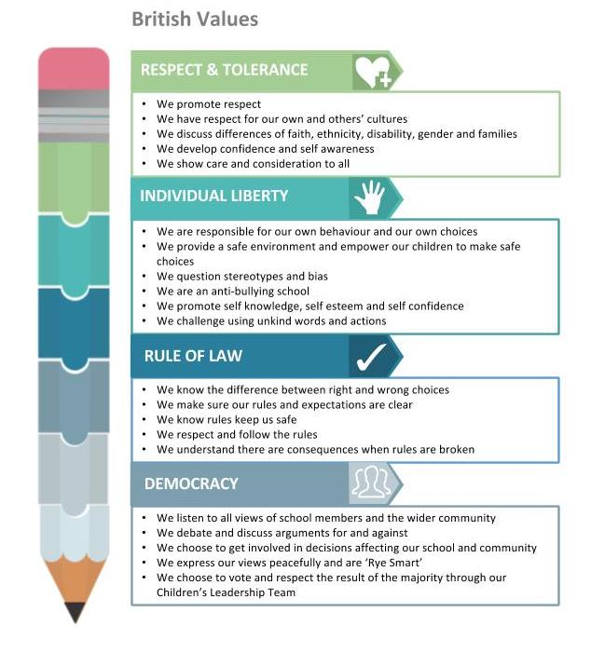
UNICEF Rights Respecting Schools Award
Rye Community Primary School is proud to be a Rights Respecting School having gained our Recognition of Commitment. We are now working towards our Level 1.

Our steering group meets every month to discuss events, progress and next steps. Our group includes; pupils, SLT, teachers, parents and other members of staff.
The children have chosen six articles from the UN Convention on the Right of the Child, as shown in the image below.
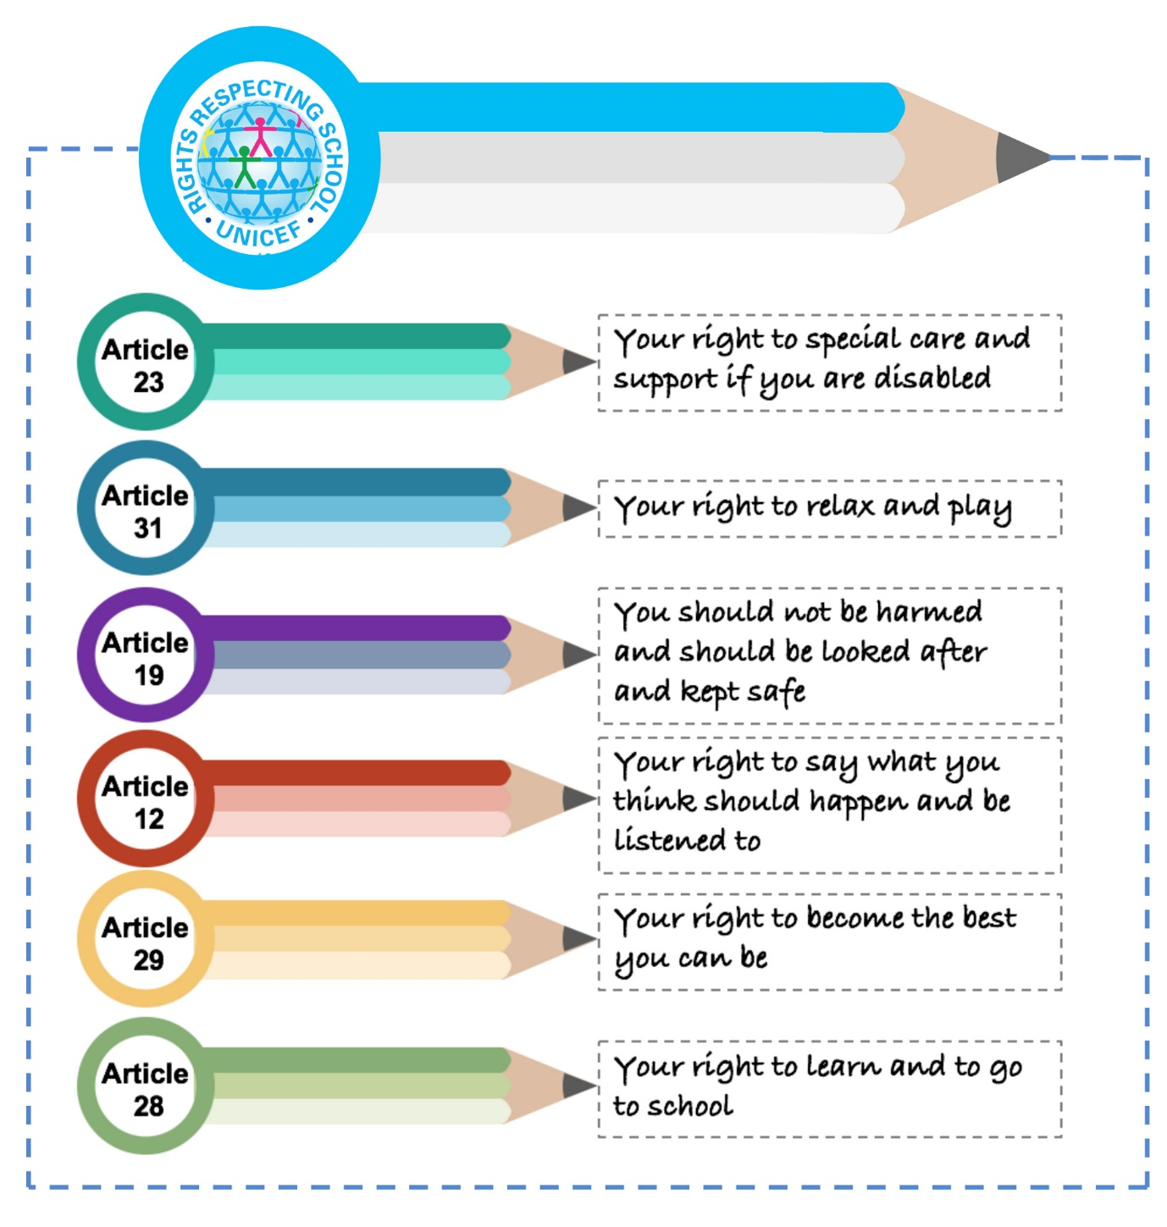

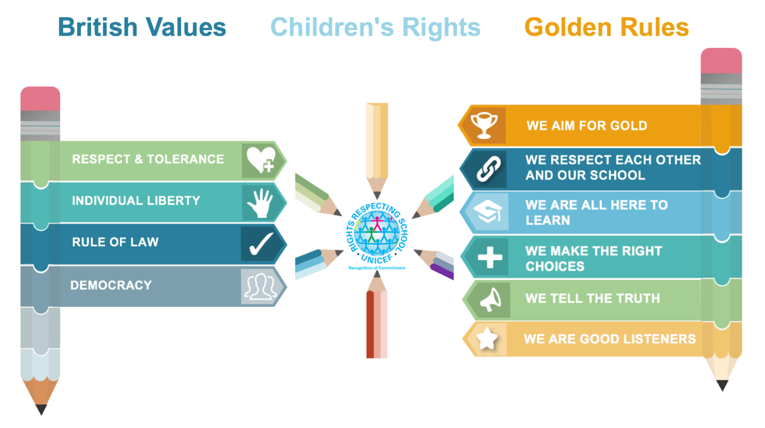
Assessment and Recording
Teachers assess the children’s work by making informal judgements as they observe them during lessons. We have clear expectations of what the pupils will know, understand and be able to do at the end of each key stage. Recorded evidence of PSHE sessions can include photos, quotations from the children, pupils work and evidence of circle time. We keep records of the contribution to the life of the school and community in photograph and video form. This is displayed in our Gateway to Learning portfolios and on our school information screen.
Our Sharing Assembly celebrates personal achievements both in and outside school. We take a weekly focus from SEAL or the Rights Respecting schools articles. Children strive weekly to achieve this goal and win the Golden Trophy. Raffle tickets used to celebrate personal achievements with regards to developing positive attitudes to learning. Busters Book Club certificates, badges and Maths Doctor coats are also used for excellent progress in reading and maths.
The PSHE subject leader keeps samples of children’s work in a portfolio. These demonstrate what the expected level of achievement is in PSHE for each age group in the school.

Resources

There are sufficient resources for PSHE teaching units in the school. SEAL themed materials are used as a basis for teaching PSHE in the following areas:-
New Beginnings
Getting on and Falling Out
Say no to Bullying
Going for Goals
Good to be Me
Relationships
Changes
Further resources are available including; www.risc.org.uk and Project Charlie.

Monitoring and Review
Monitoring of the standards of children’s work and of the quality of teaching in PSHE/SEAL is the responsibility of the PSHE subject leader. The PSHE subject leader monitors children’s work, wall displays, planning and carries out a pupil voice three times a year. The work of the PSHE subject leader also involves supporting colleagues in the teaching of PSHE/SEAL, being informed about current developments in the subject.

